Chapter 2



# Project Based Learning

**Title of Project : Financial Management Tool: Develop a web-based tool for personal finance management, integrating budgeting, expense tracking, and financial goal setting with a clear and intuitive interface.**

| **Sr.No** | **Name of Students** | **PRN No** |
| --- | --- | --- |
| 1 | Gaurav Jadhav | B24IT1054 |
| 2 | Shreyash Mandlapure | B24IT1130 |
| 3 | Tanushree Patil | B24IT1049 |
| 4 | Sanika Pujari | B24IT1058 |

**Date: Faculty In-Charge**

## 

## **Chapter 1**

#### **1.1 Brief Overview of the Project**

The project centers around the design of a mobile application, "Finlytic," aimed at simplifying financial tracking for users. The app provides tools for users to manage their income and expenses, monitor transactions, set savings goals, and analyze their spending habits. The design includes user-friendly interfaces for login/signup, account management, and various financial management features.

#### **1.2 Objective**

The primary objective of Finlytic is to empower users to gain better control over their finances by providing an intuitive and efficient platform to track income and expenses. The app aims to simplify the complexities of personal finance management through clear visualizations and easy-to-use tools. Ultimately, Finlytic's goal is to promote financial awareness and facilitate informed decision-making.

#### **1.3 Importance of UX in Making Financial Tracking Simple and Accessible**

User experience (UX) is crucial in the design of Finlytic to ensure that financial tracking is both simple and accessible. The app's UX focuses on creating an intuitive navigation flow, utilizing clear and concise language, and presenting data in an easily understandable format. By prioritizing a user-centered design, Finlytic can help users of varying financial literacy levels to effectively manage their money and achieve their financial goals.

## 

## **Chapter 2**

### **2.1 Research Methods**

To inform the design of Finlytic, a mixed-methods approach was employed, combining quantitative and qualitative research methods:

* **Surveys:** Online surveys were distributed to a broad audience to gather data on general financial habits, challenges, and feature preferences.
* **Interviews:** In-depth interviews were conducted with a smaller group of individuals to gain a deeper understanding of their financial behaviors, pain points, and needs.
* **Competitive Analysis:** A competitive analysis was performed to evaluate existing personal finance applications, identifying their strengths, weaknesses, and areas for differentiation.

### **2.2 Survey Results & Interviews**

**Survey Insights:**

* **Common Financial Challenges:** Many reported difficulties in tracking expenses consistently, creating and adhering to budgets, and saving for specific goals.
* **User Needs:** Key user needs identified were:
  + Simple and intuitive interface for easy tracking

Key Pain Points Identified:

* Inconsistent tracking across apps
* No proactive alerts for overspending
* Lack of motivation tools for goal saving
* Overwhelming interfaces with poor categorization

**Functional Requirements:**

* User authentication (login, signup, password reset)
* Transaction recording (income and expenses)
* Data visualization (charts and graphs)
* Savings goal setting and tracking
* Category management
* Profile management
* Help and support

**Non-Functional Requirements:**

* Security (data encryption, secure authentication)
* Usability (intuitive navigation, accessibility)
* Performance (fast loading times, responsiveness)
* Reliability (data accuracy, minimal errors)
* Scalability (ability to handle a growing user base)

### **2.3 User Personas**

#### **Persona 1: Gaurav Jadhav– The Student**

* **Age**: 19
* **Goals**: Track college expenses, save for a trip
* **Frustrations:** Misses budget targets due to poor visibility
* **Behaviors:** Uses phone for all finance-related tasks
* **Motivation:** Wants to be financially independent

#### **Persona 2: Rohan Mehta – The Working Professional**

* **Age:** 32
* **Goals:** Manage monthly expenses, invest, save for home
* **Frustrations:** Uses spreadsheets that are time-consuming
* **Behaviors:** Works full-time, prefers mobile + desktop sync
* **Motivation:** Financial stability, family savings

#### **Persona 3: Kavita Rao – The Freelancer/Small Business Owner**

* **Age:** 40
* **Goals:** Track variable income and taxes
* **Frustrations:** Difficulty managing cash flow and invoices
* **Behaviors:** Needs categorized reports for clients and tax
* **Motivation:** Maximize profit, stay audit-ready

**2.4 User Journey Maps: Tracking Personal Finances**

**Stage 1: Trigger/Awareness**

* Description: The user recognizes a need to manage their finances better. This might be triggered by:
  + Not knowing where their money is going.
  + Difficulty saving money.
  + Feeling stressed about debt.
  + Wanting to achieve a financial goal (e.g., buying a house).
* User Actions:
  + Reflects on their current financial situation.
  + Searches for solutions (e.g., online articles, apps, spreadsheets).
* Touchpoints:
  + Personal reflection.
  + App store search.
  + Recommendations from friends.
* User Thoughts/Feelings:
  + Anxiety, frustration, or a desire for control.

**Stage 2: Onboarding**

* Description: The user begins using the Finlytic app.
* User Actions:
  + Download the Finlytic app from the app store.
  + Opens the app and goes through the onboarding process.
  + Creates an account (provides personal information or uses social login).
  + May connect bank accounts or cards (if the app supports it - not explicitly shown but a common feature).
  + Familiarizes themselves with the app's interface.
* Touchpoints:
  + App store listing.
  + App onboarding screens.
  + Registration/login screens.
  + Initial app dashboard.
* User Thoughts/Feelings:
  + Excitement, hopefulness, or potential overwhelm.

**Stage 3: Regular Tracking**

* Description: The user consistently records their income and expenses.
* User Actions:
  + Manually entered transaction details (date, amount, category, description).
  + Categorizes transactions (e.g., food, rent, transport).
  + Views transaction history.
  + Checks account balances.
  + Uses search and filter functions to find specific transactions.
* Touchpoints:
  + Transaction entry screens.
  + Category selection.
  + Transaction list.
  + Dashboard with summary information.
  + Calendar view.
* User Thoughts/Feelings:
  + Can range from diligence and satisfaction to frustration with manual entry.

**Stage 4: Analysis and Insights**

* Description: The user reviews their financial data to gain insights and make decisions.
* User Actions:
  + Views spending summaries and visualizations (charts, graphs).
  + Analyzes spending patterns over time (daily, weekly, monthly).
  + Identifies areas where they can save money or reduce expenses.
  + Sets and monitors savings goals.
  + Generates reports (if available).
* Touchpoints:
  + Dashboard with charts and graphs.
  + Analysis/reports section.
  + Goal setting features.
* User Thoughts/Feelings:
  + Empowerment, motivation, or potentially disappointment if facing financial challenges.

**Stage 5: Management and Optimization**

* Description: The user makes adjustments to their financial habits based on the insights gained.
* User Actions:
  + Creates a budget.
  + Reduces spending in certain categories.
  + Increases savings contributions.
  + Set up reminders or notifications.
  + Adjusts financial goals.
* Touchpoints:
  + Profile settings.
  + Notification settings.
* User Thoughts/Feelings:
  + Determination, hopefulness, or a sense of accomplishment.

**Pain Points:**

* Manual Data Entry: Entering transactions manually can be time-consuming and tedious, leading to user frustration and potential inaccuracies.
* Category Management: Users may struggle to categorize transactions consistently or find the right category, resulting in inaccurate reports.
* Data Interpretation: Users may find it challenging to understand and interpret financial data, especially if presented in a complex or confusing way.
* Security Concerns: Users may have concerns about the security of their financial data, especially when linking bank accounts or cards.
* Lack of Automation: Limited automation (e.g., automatic transaction import, recurring expense tracking) can increase the effort required from users.
* App Performance: Slow loading times or app crashes can disrupt the user experience and lead to frustration.

**Opportunities:**

* Automation: Implement features like automatic transaction import, smart categorization, and recurring expense tracking to reduce manual effort.
* Personalization: Provide personalized insights, recommendations, and budgeting tips based on the user's spending habits and financial goals.
* Improved Data Visualization: Use clear, concise, and engaging visualizations to make financial data easier to understand.
* Enhanced Security: Employ robust security measures (e.g., encryption, multi-factor authentication) to protect user data and build trust.
* Proactive Notifications: Provide timely and relevant notifications to remind users of upcoming bills, alert them to potential overspending, and encourage savings.
* Gamification: Incorporate gamification elements (e.g., rewards, badges, progress bars) to make financial tracking more engaging and motivating.
* Accessibility: Ensure the app is accessible to users with disabilities by adhering to accessibility guidelines.
* Integration: Integrate with other financial tools and services (e.g., banking apps, investment platforms) to provide a seamless user experience.

**Chapter 3**

**3.1 Heuristic Evaluation of Existing Finance Apps**

A heuristic evaluation was conducted on two popular finance applications, "FinanceApp A" and "BudgetBuddy," using Nielsen's 10 Usability Heuristics. This evaluation aimed to identify potential usability issues that could inform the design of Finlytic.

**Heuristic Evaluation Framework:**

Nielsen's 10 Usability Heuristics were used as the framework:

1. **Visibility of system status:** The app should keep users informed about what is happening, through appropriate feedback within a reasonable time.
2. **Match between system and the real world:** The app should speak the users' language, with words, phrases, and concepts familiar to the user, rather than system-oriented terms.
3. **User control and freedom:** Users often choose system functions by mistake and will need a clearly marked "emergency exit" to leave the unwanted state without having to go through an extended dialogue.
4. **Consistency and standards:** Users should not have to wonder whether different words, situations, or actions mean the same thing.
5. **Error prevention:** Even better than good error messages is careful design which prevents a problem from occurring in the first place.
6. **Recognition rather than recall:** Minimize the user's memory load by making objects, actions, and options visible.
7. **Flexibility and efficiency of use:** Accelerators — unseen by the novice user — may often speed up the interaction for the expert user such that the app can cater to both inexperienced and experienced users.
8. **Aesthetic and minimalist design:** Interfaces should not contain information which is irrelevant or rarely needed.
9. **Help users recognize, diagnose, and recover from errors:** Error messages should be expressed in plain language (no codes), precisely indicate the problem, and constructively suggest a solution.
10. **Help and documentation:** Even though it is better if the system can be used without documentation, it may be necessary to provide help and documentation.

**3.1.1 FinanceApp A**

* **Strengths:** Clear visibility of system status through transaction confirmations and loading indicators.
  + Good match between system and real-world language, using familiar financial terms.
* **Usability Issues:**
  + **Difficult Navigation:** The main navigation menu is cluttered, making it hard for users to find specific features. (Heuristic 4: Consistency and standards; Heuristic 8: Aesthetic and minimalist design)
  + **Complex Onboarding:** The initial setup process requires too many steps and requests excessive personal information, leading to user drop-off. (Heuristic 2: Match between system and the real world; Heuristic 5: Error prevention)

**3.1.2 BudgetBuddy**

* **Strengths:**
  + Aesthetic and minimalist design with a clean interface and clear data visualization.
  + Strong error prevention mechanisms, guiding users through input fields and preventing common mistakes.
* **Usability Issues:**
  + **Lack of Visual Clarity:** While minimalist, some key information is not visually prominent enough, making it easy to miss important alerts or summaries. (Heuristic 1: Visibility of system status; Heuristic 8: Aesthetic and minimalist design)
  + **Overwhelming Data Presentation:** While data is well-organized, the sheer volume of information on some screens can be overwhelming for novice users. (Heuristic 7: Flexibility and efficiency of use; Heuristic 8: Aesthetic and minimalist design)

**3.2 Key UX Issues Identified (Across Apps)**

Based on the heuristic evaluation, several key UX issues were identified across the analyzed finance apps:

* **Difficult Navigation:** Inconsistent or cluttered navigation menus hinder users' ability to find and use app features efficiently.
* **Lack of Visual Clarity:** Insufficient use of visual hierarchy and cues can make it challenging for users to quickly grasp important information.
* **Complex Onboarding:** Lengthy or intrusive onboarding processes can deter new users and lead to abandonment.
* **Overwhelming Data Presentation:** Presenting too much information at once can overwhelm users, especially those with limited financial literacy.

## 

## **Chapter 4**

### **4.1 Task Flows**

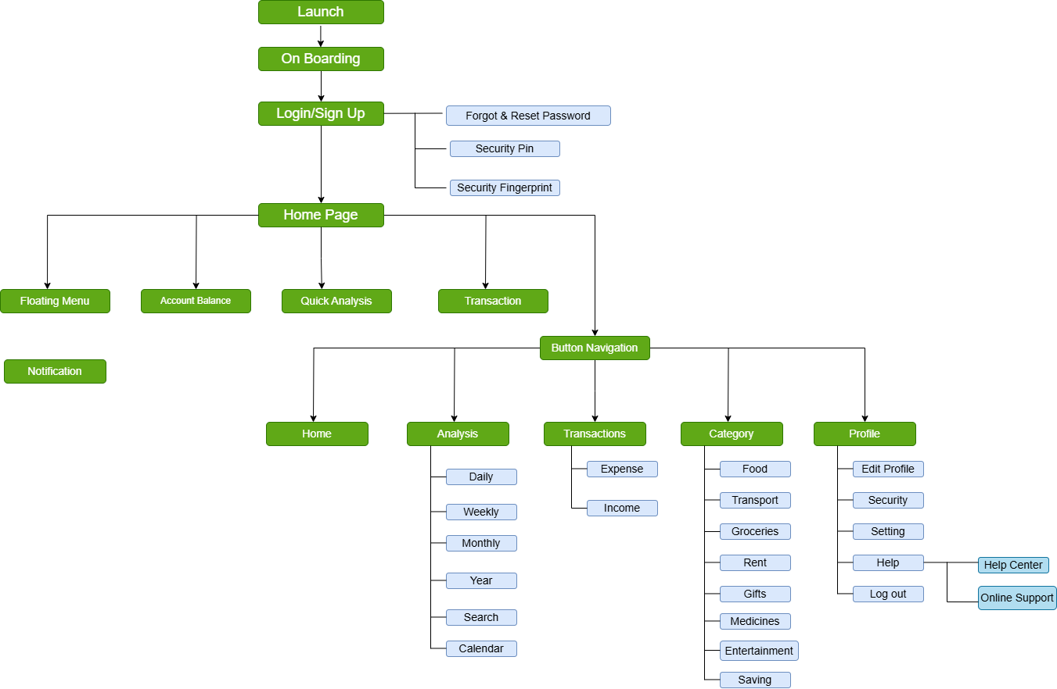

### 

**4.2 Sitemap**

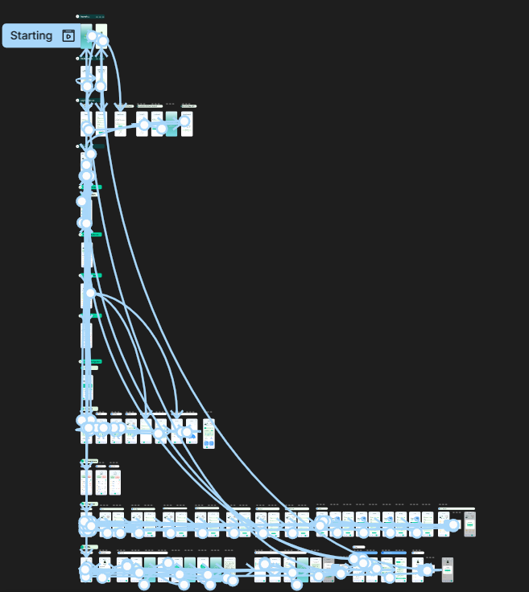

## **Chapter 5**

### **5.1 Low-Fidelity Wireframes**

* Basic screen layouts for dashboard, transaction input, reports.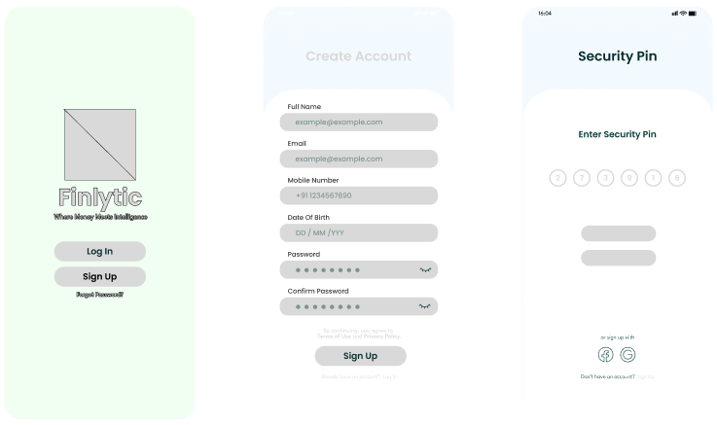

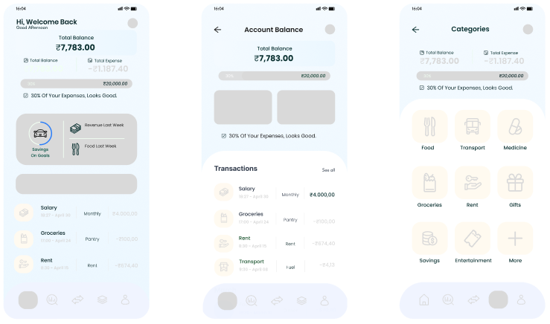

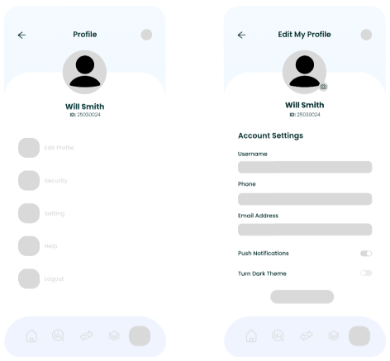

### 

### 

### **5.2 High-Fidelity Prototype**

* Figma designs showcasing the final UI.

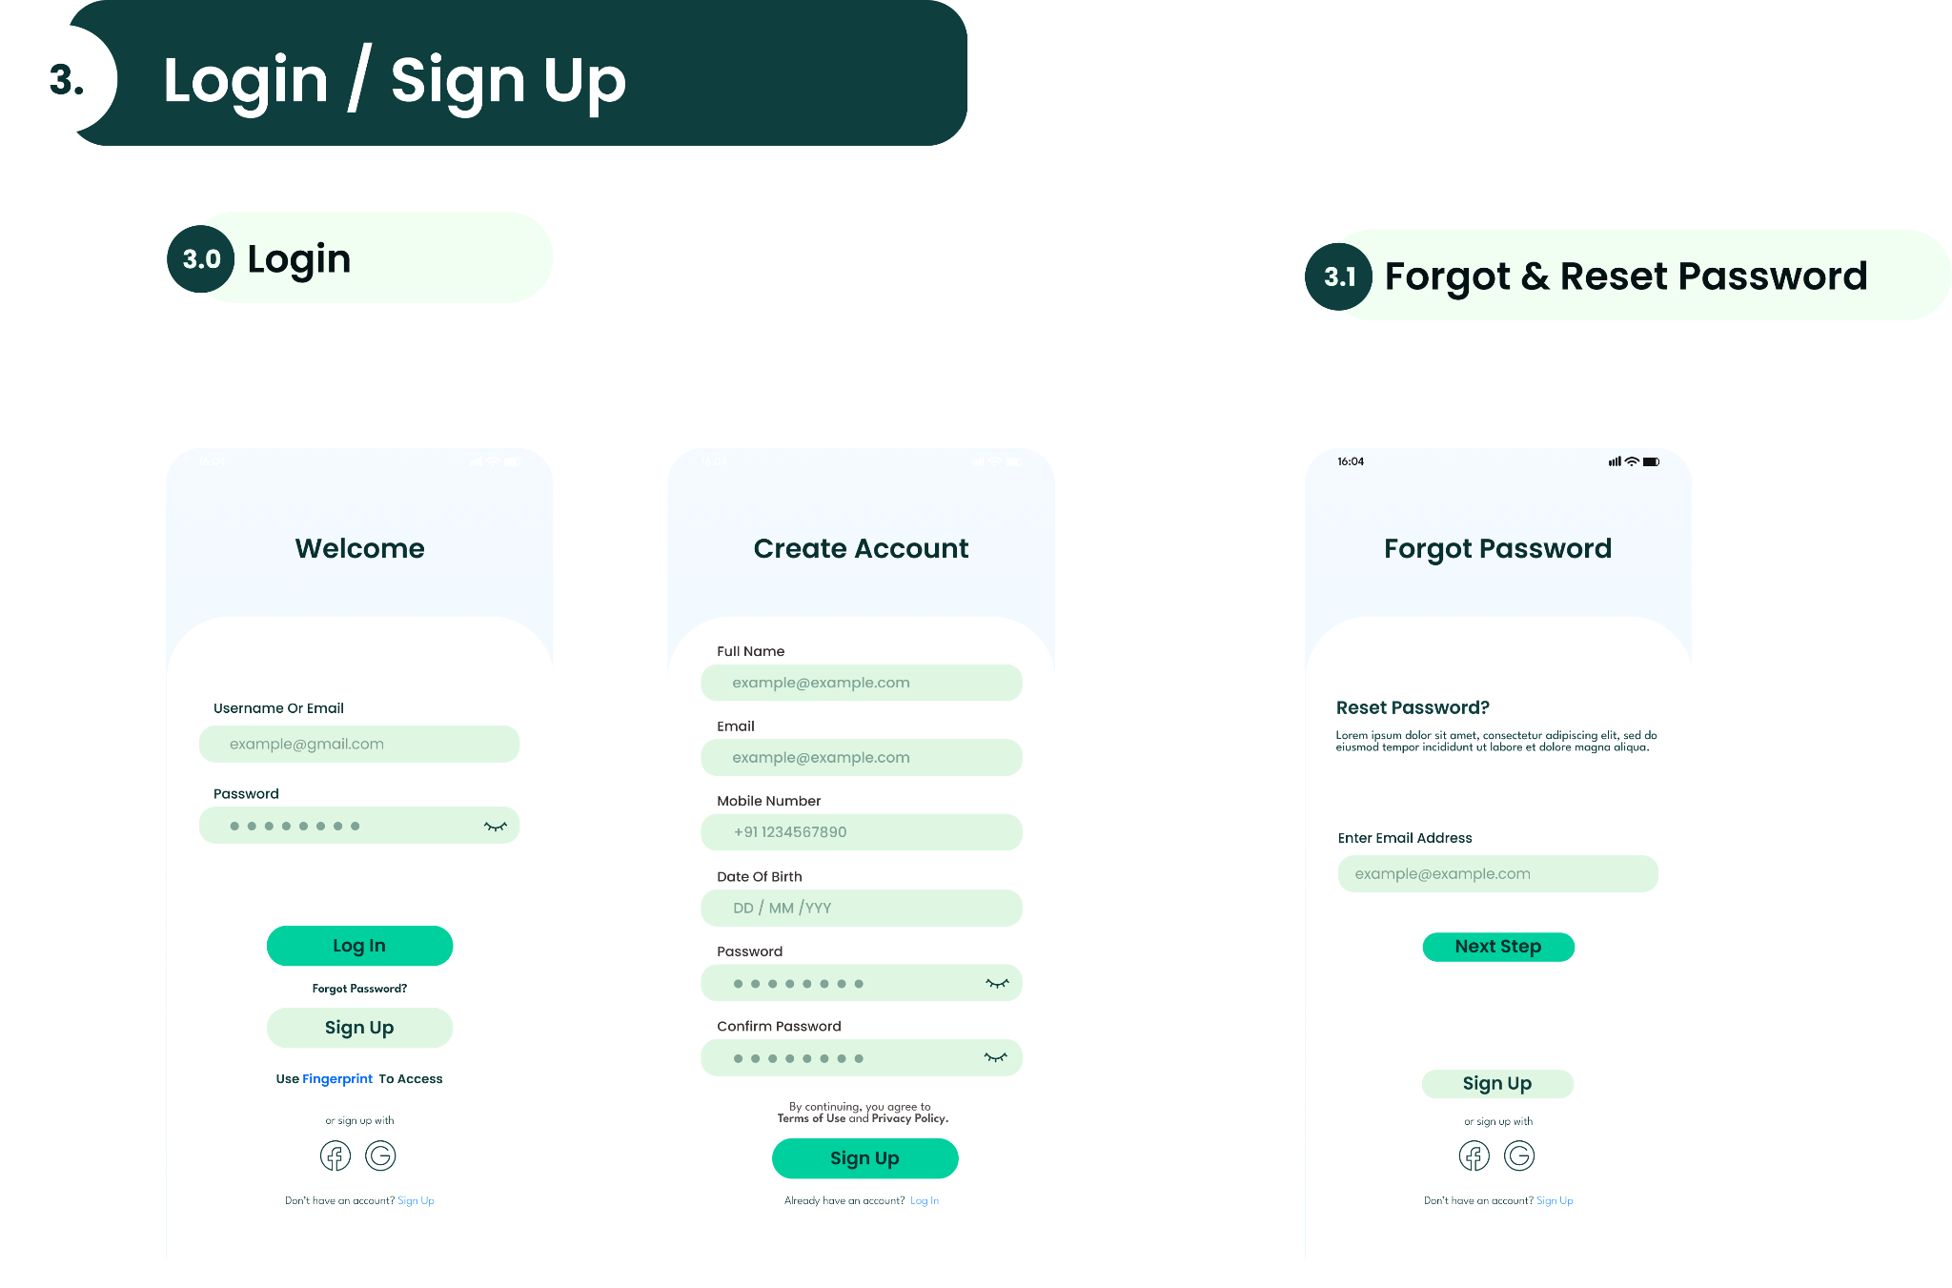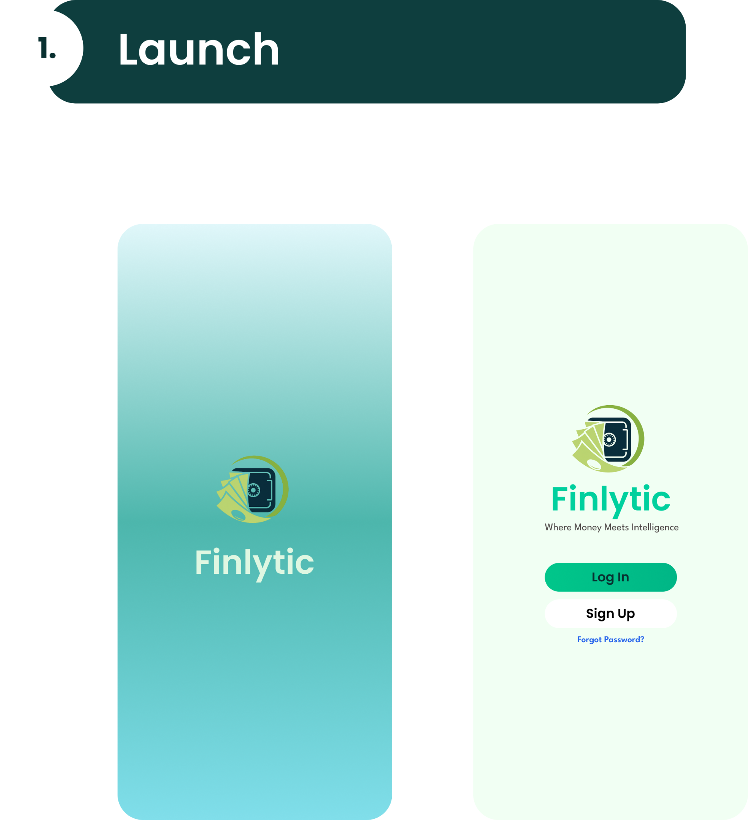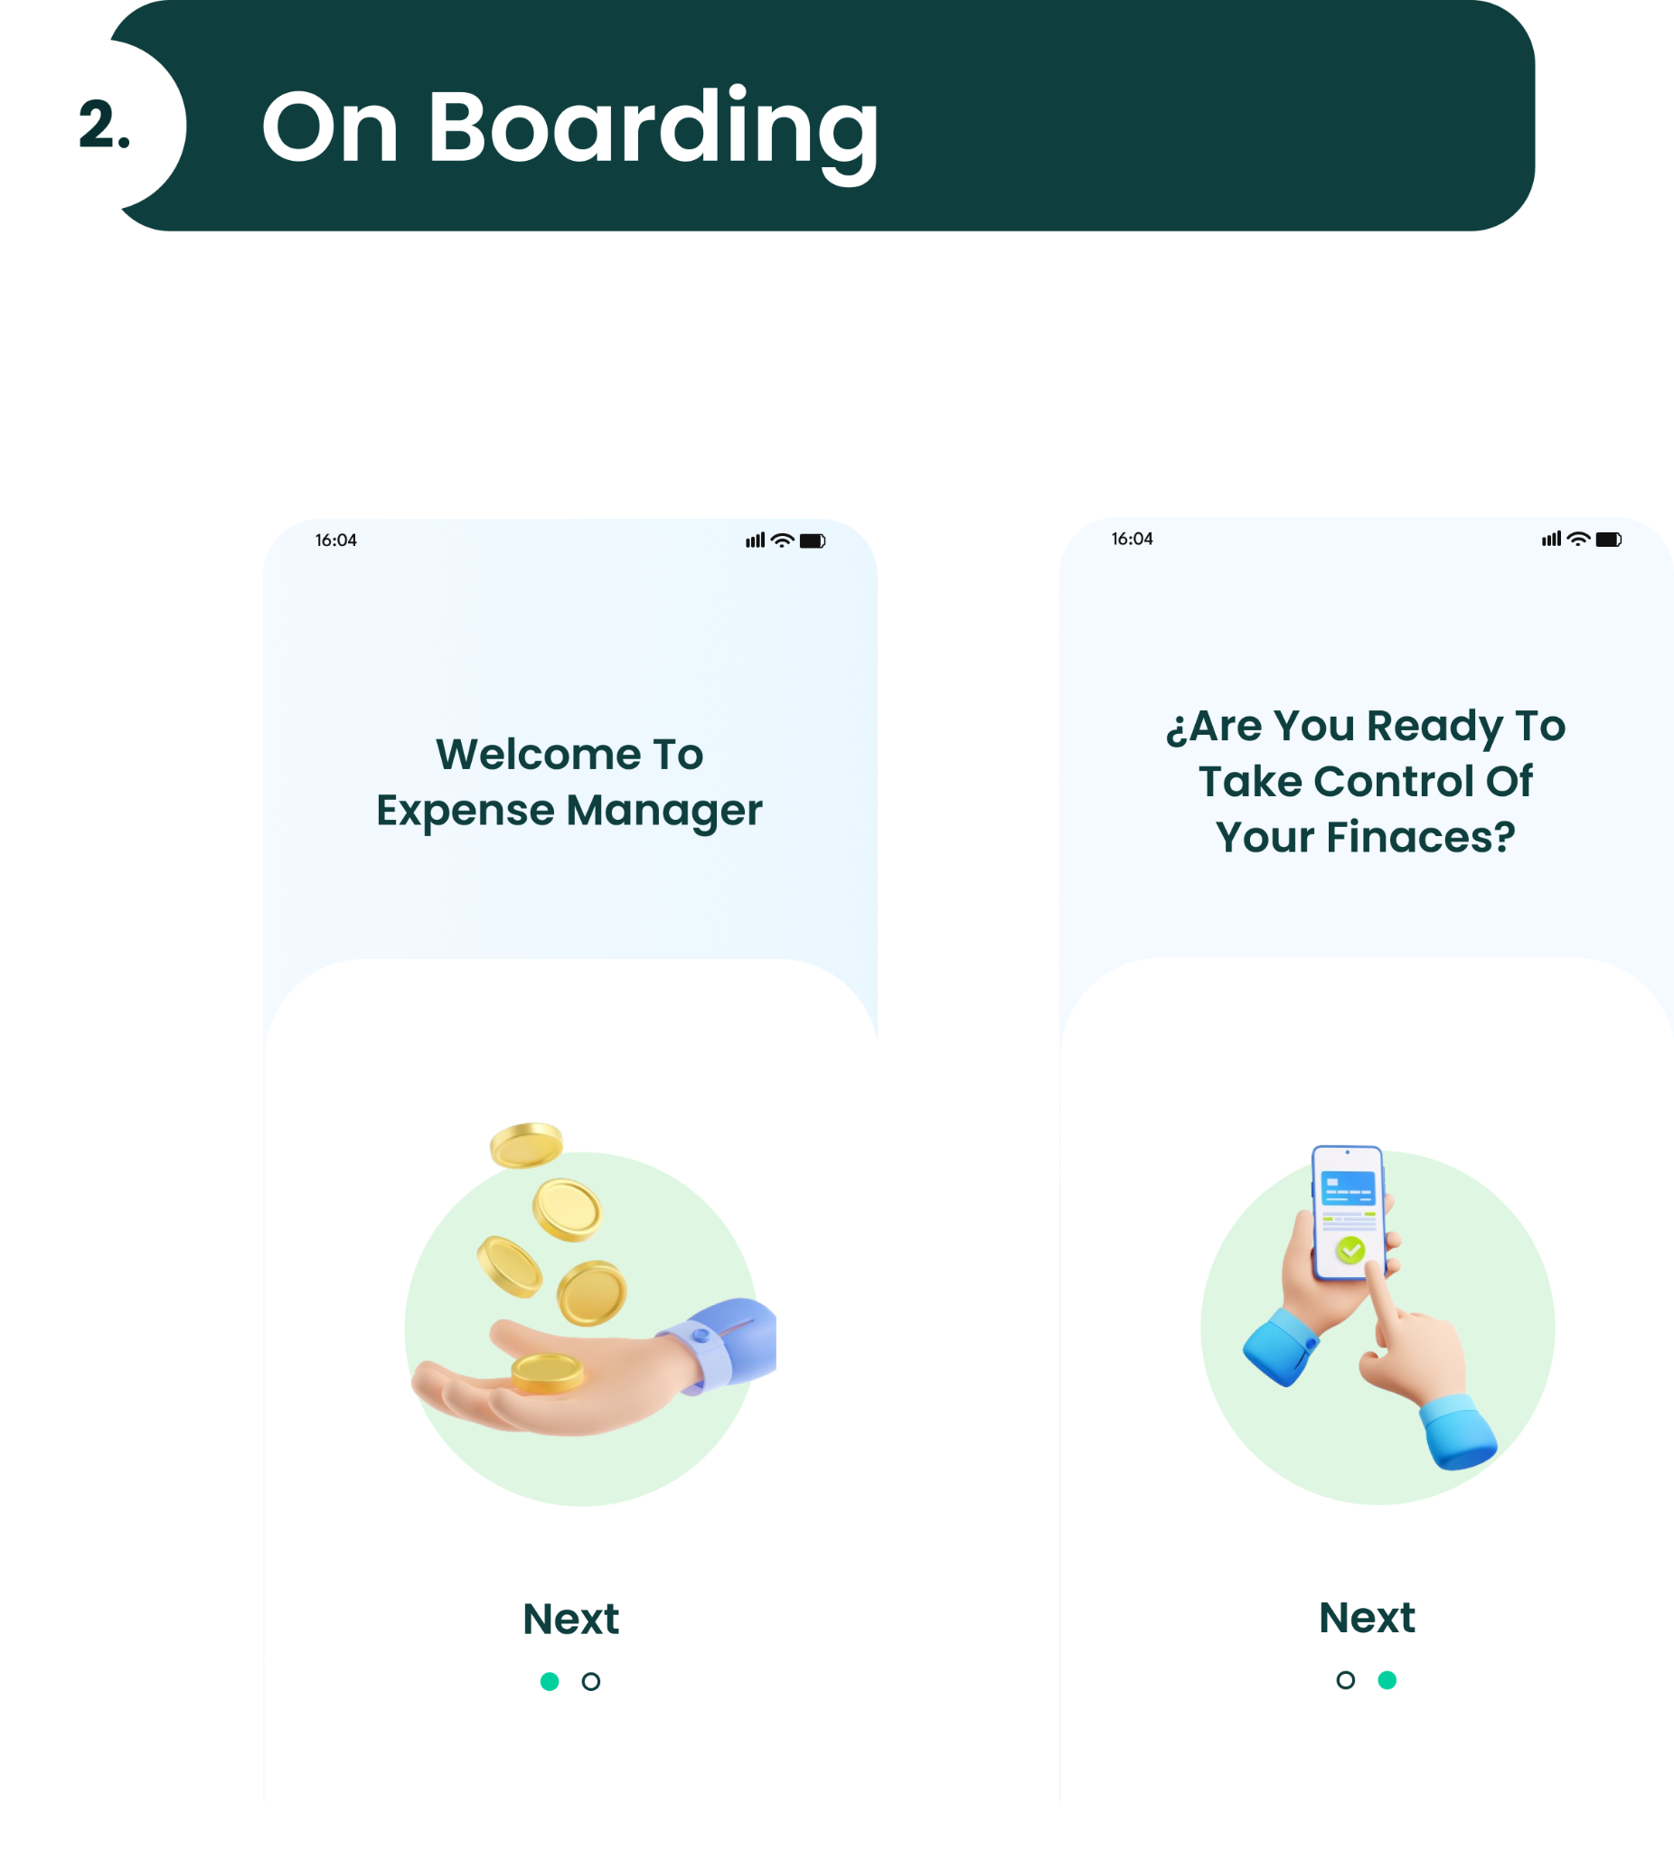



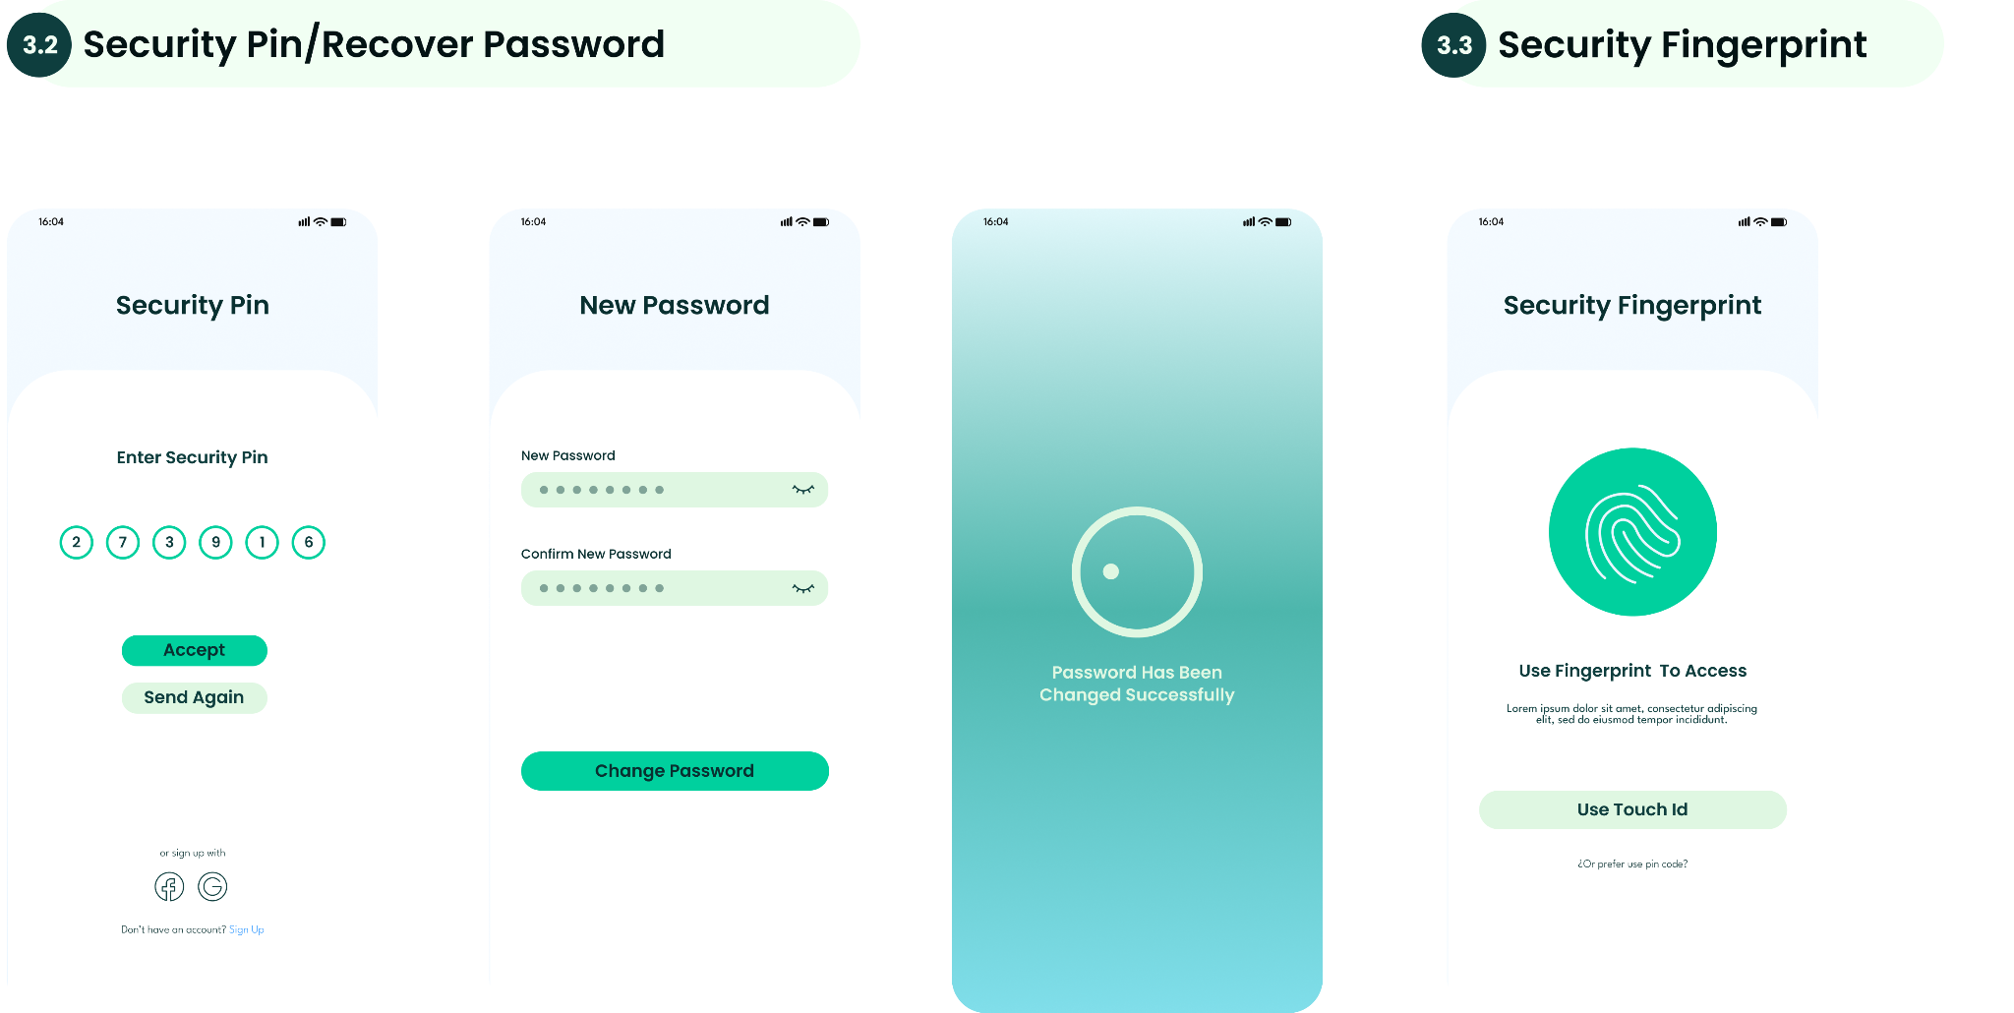

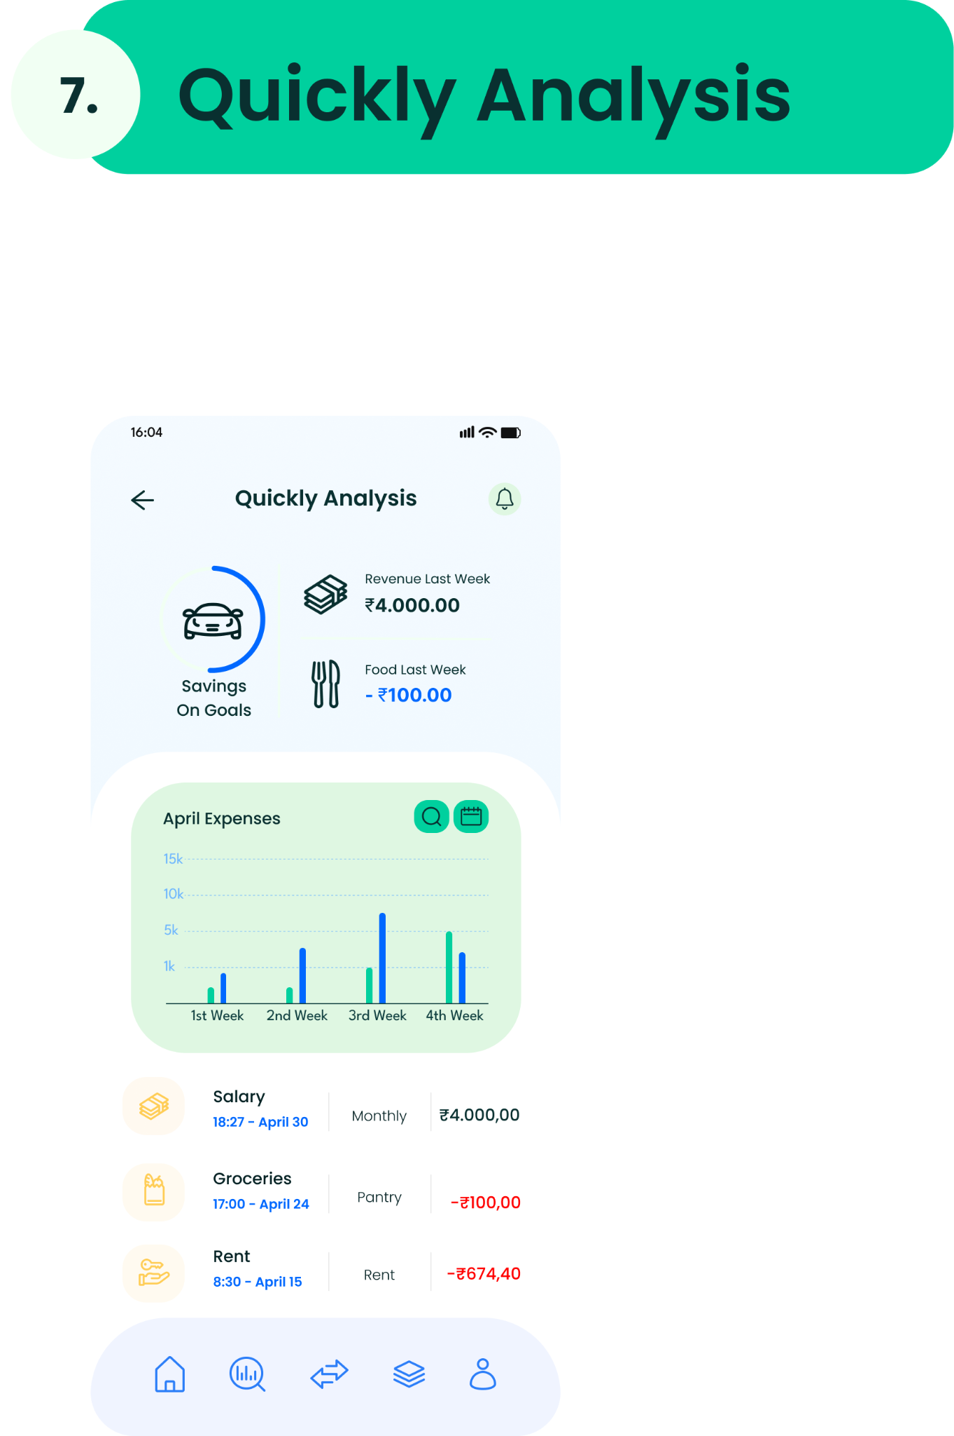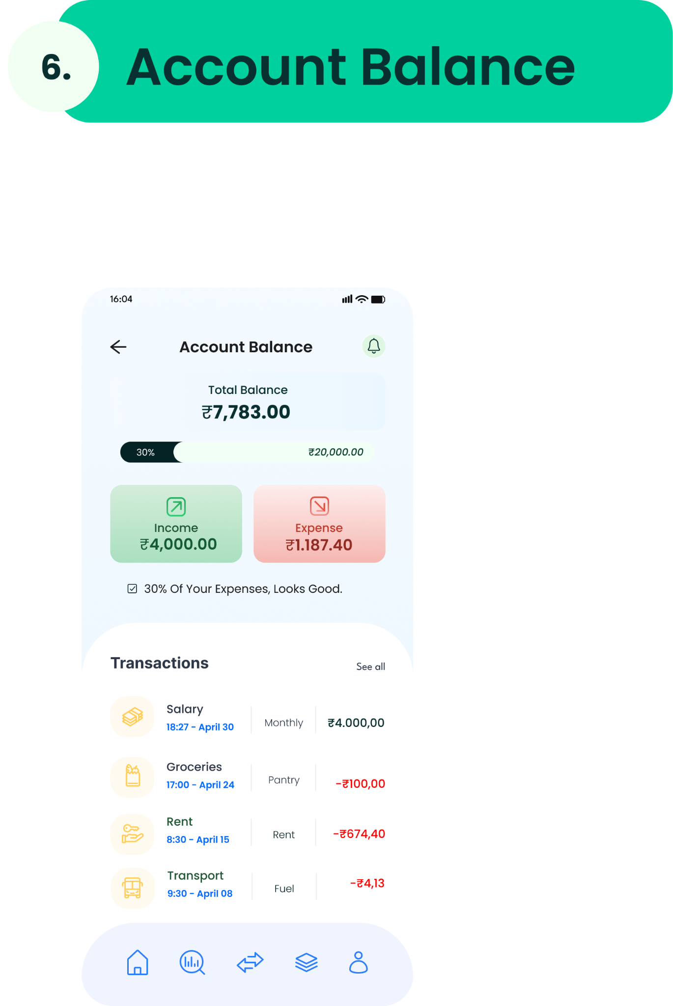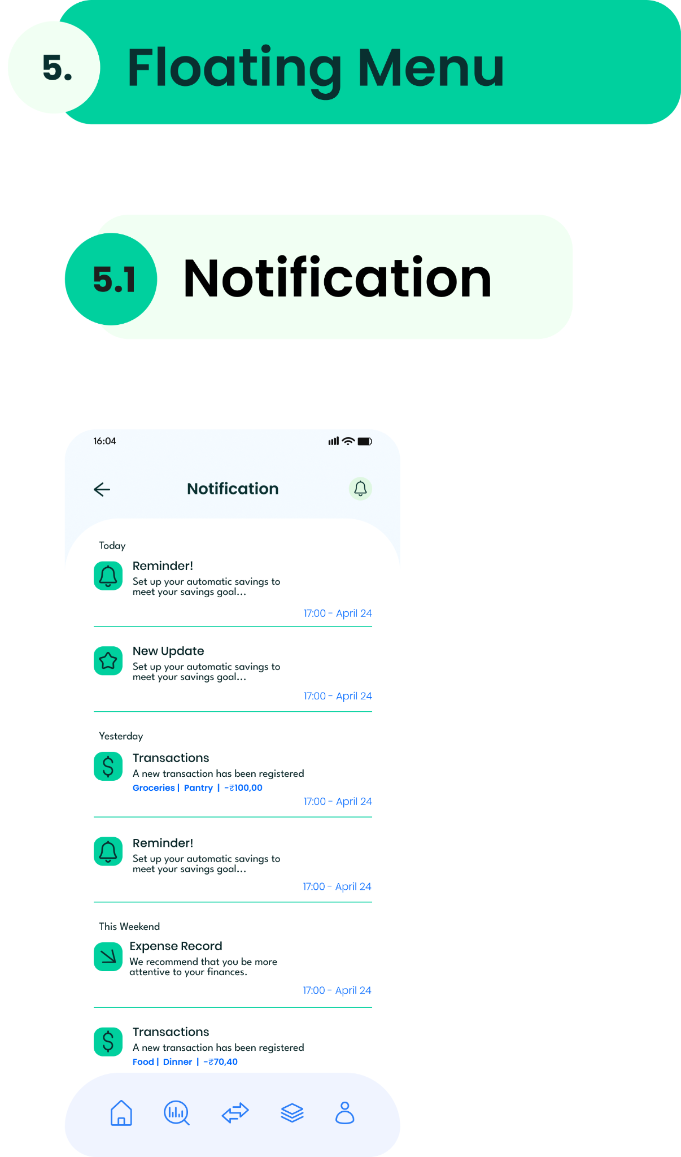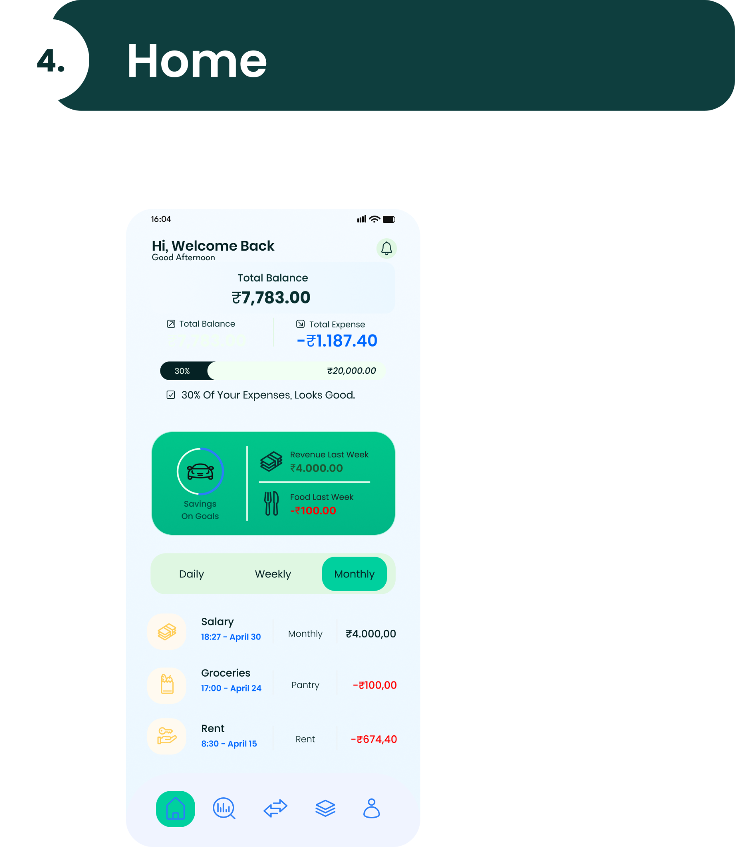

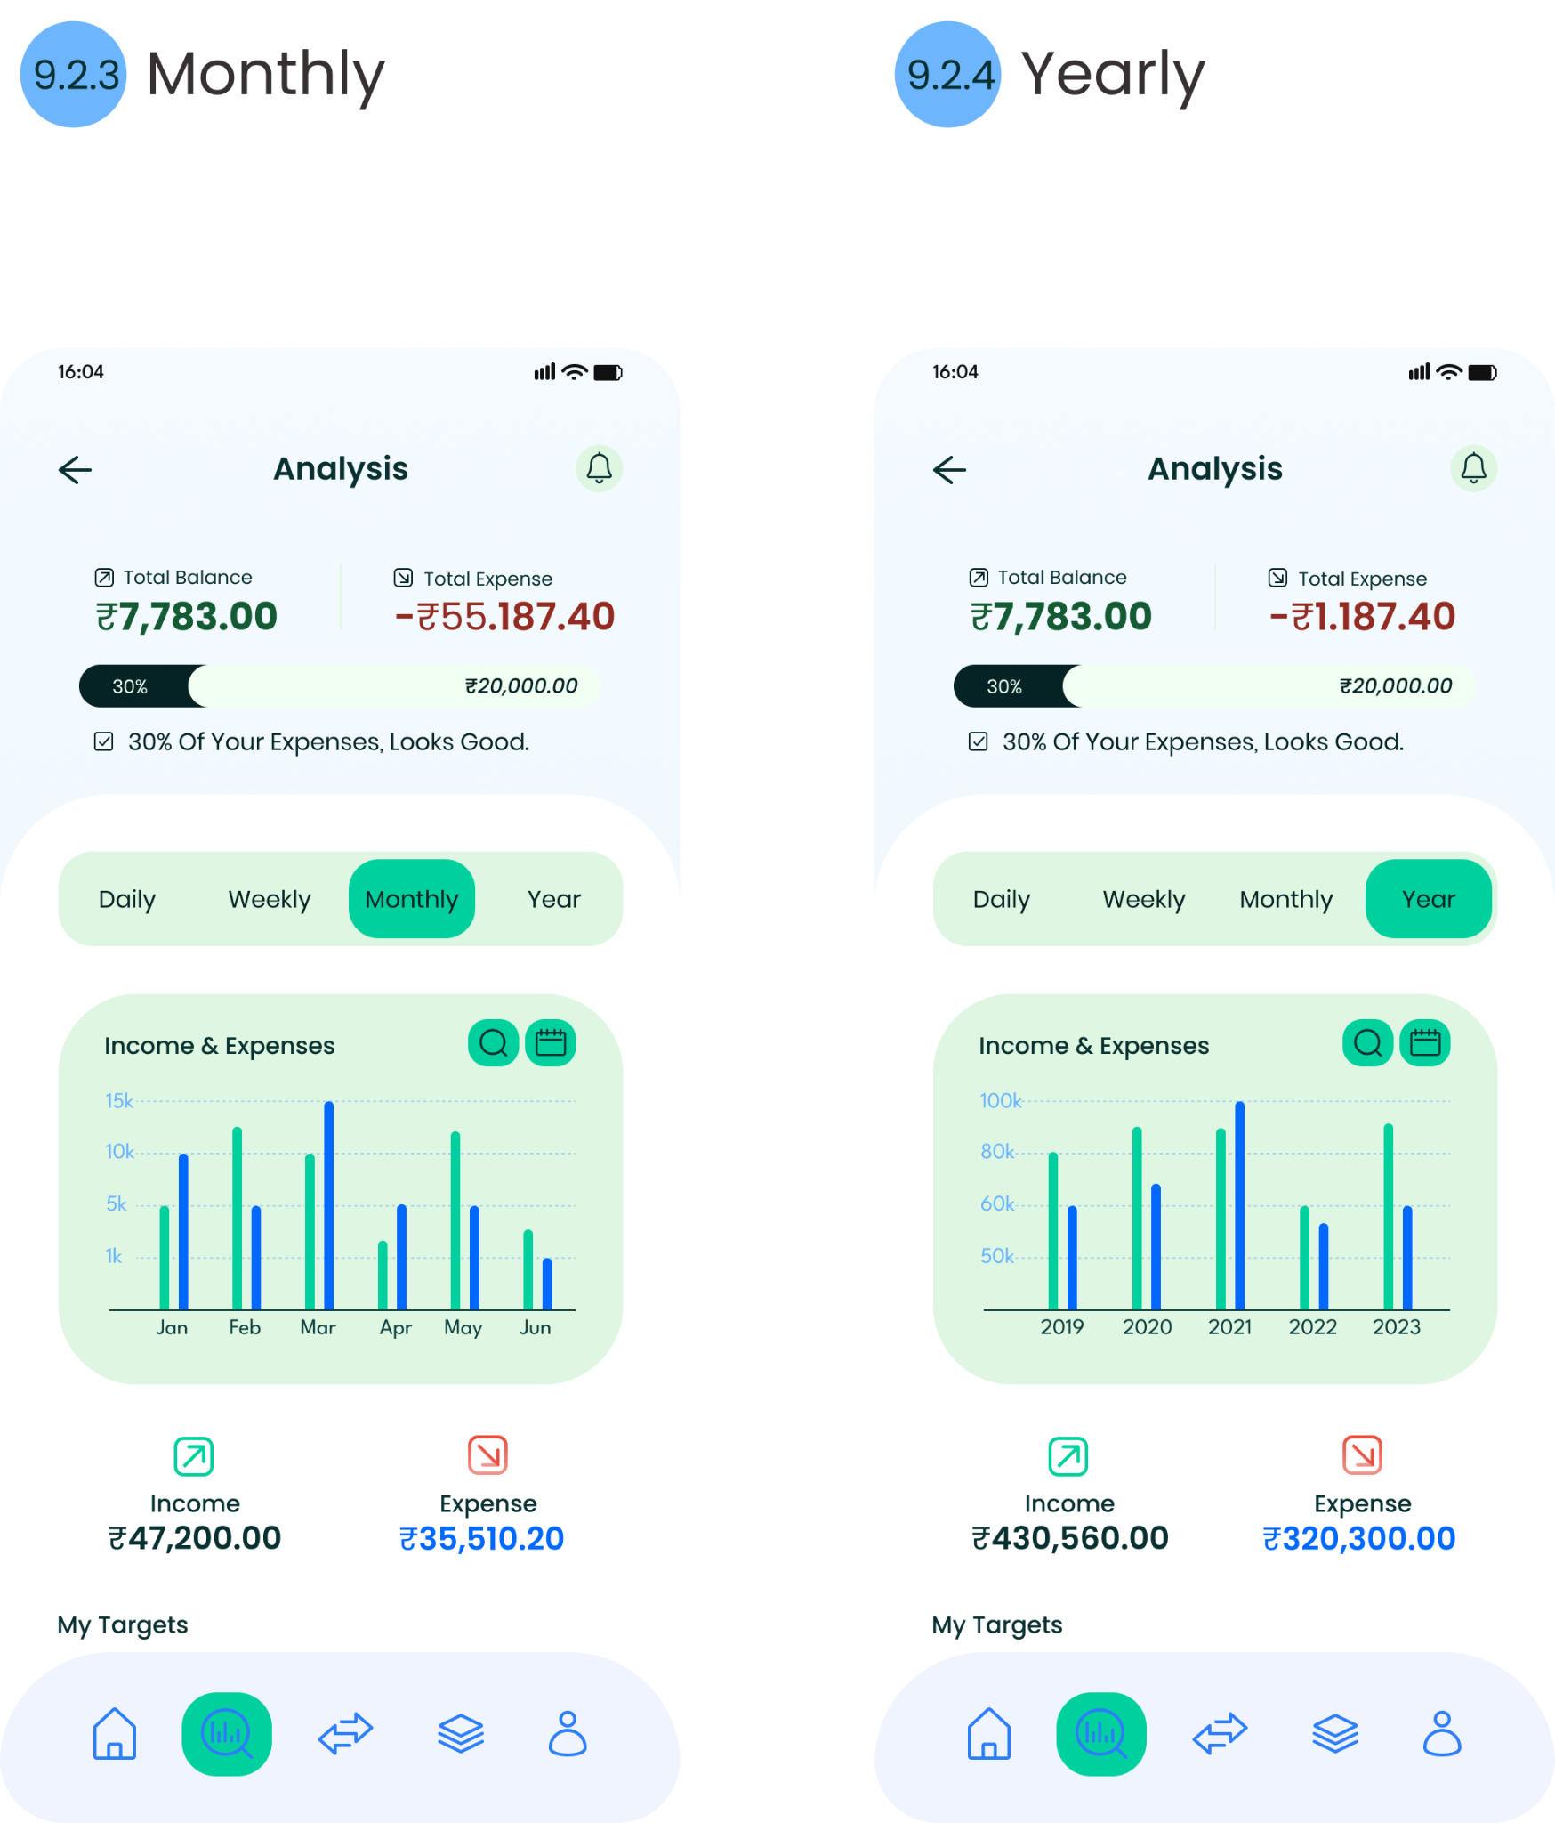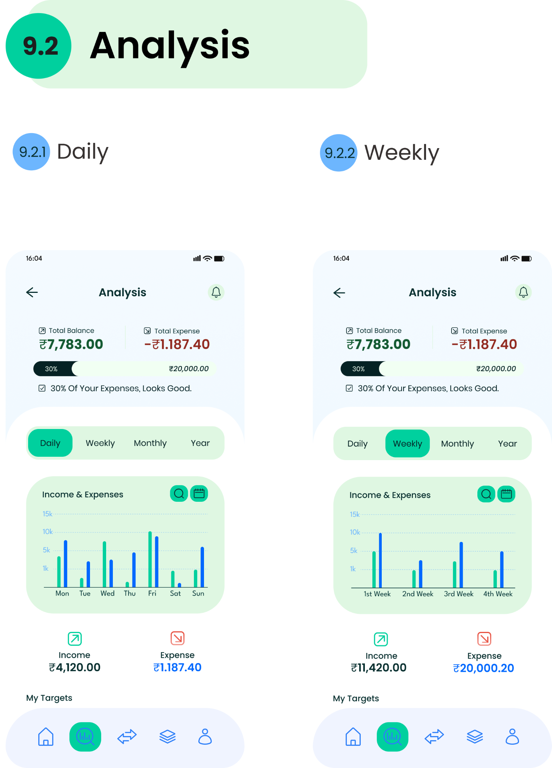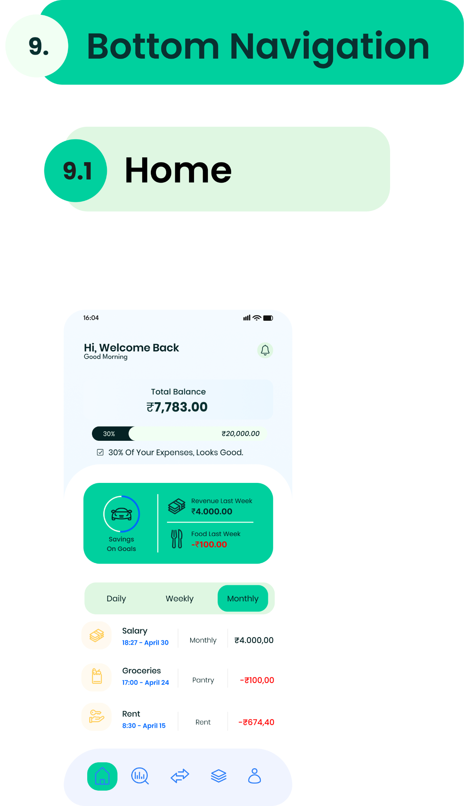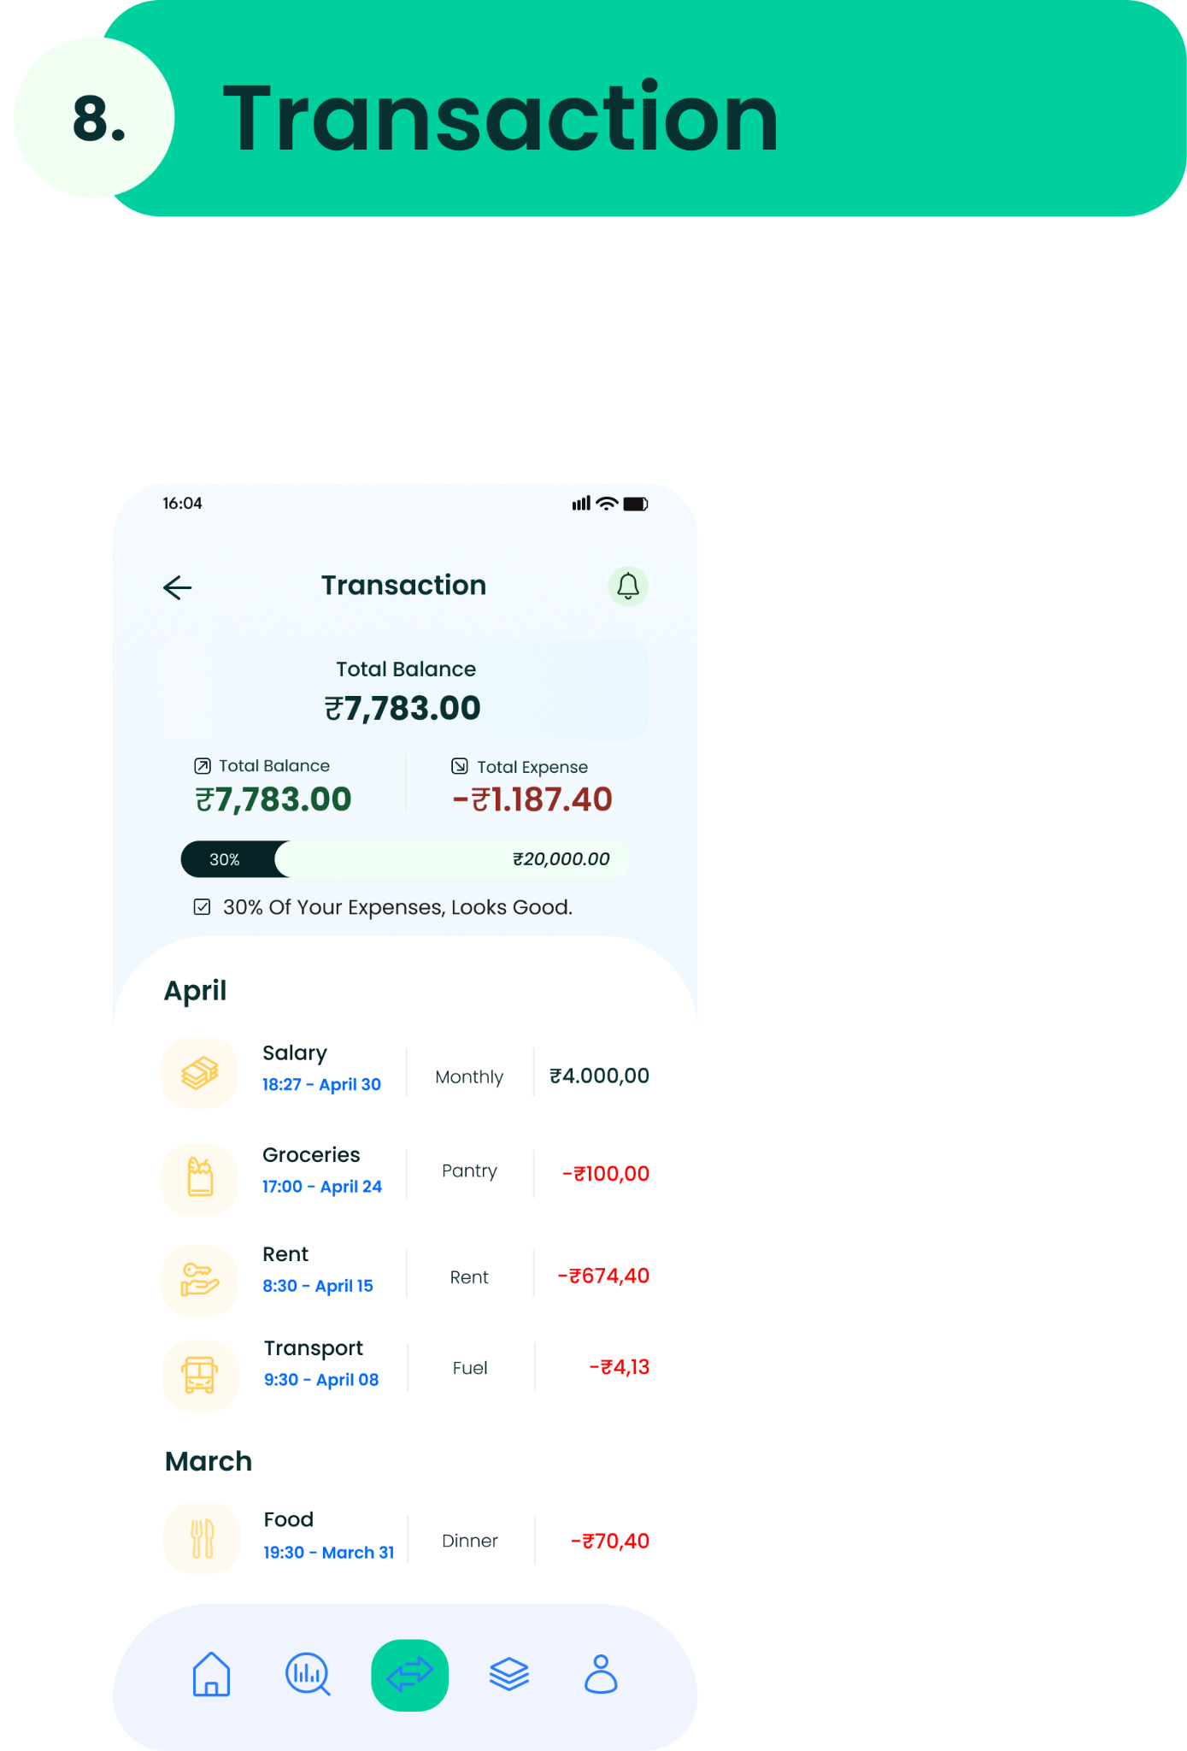

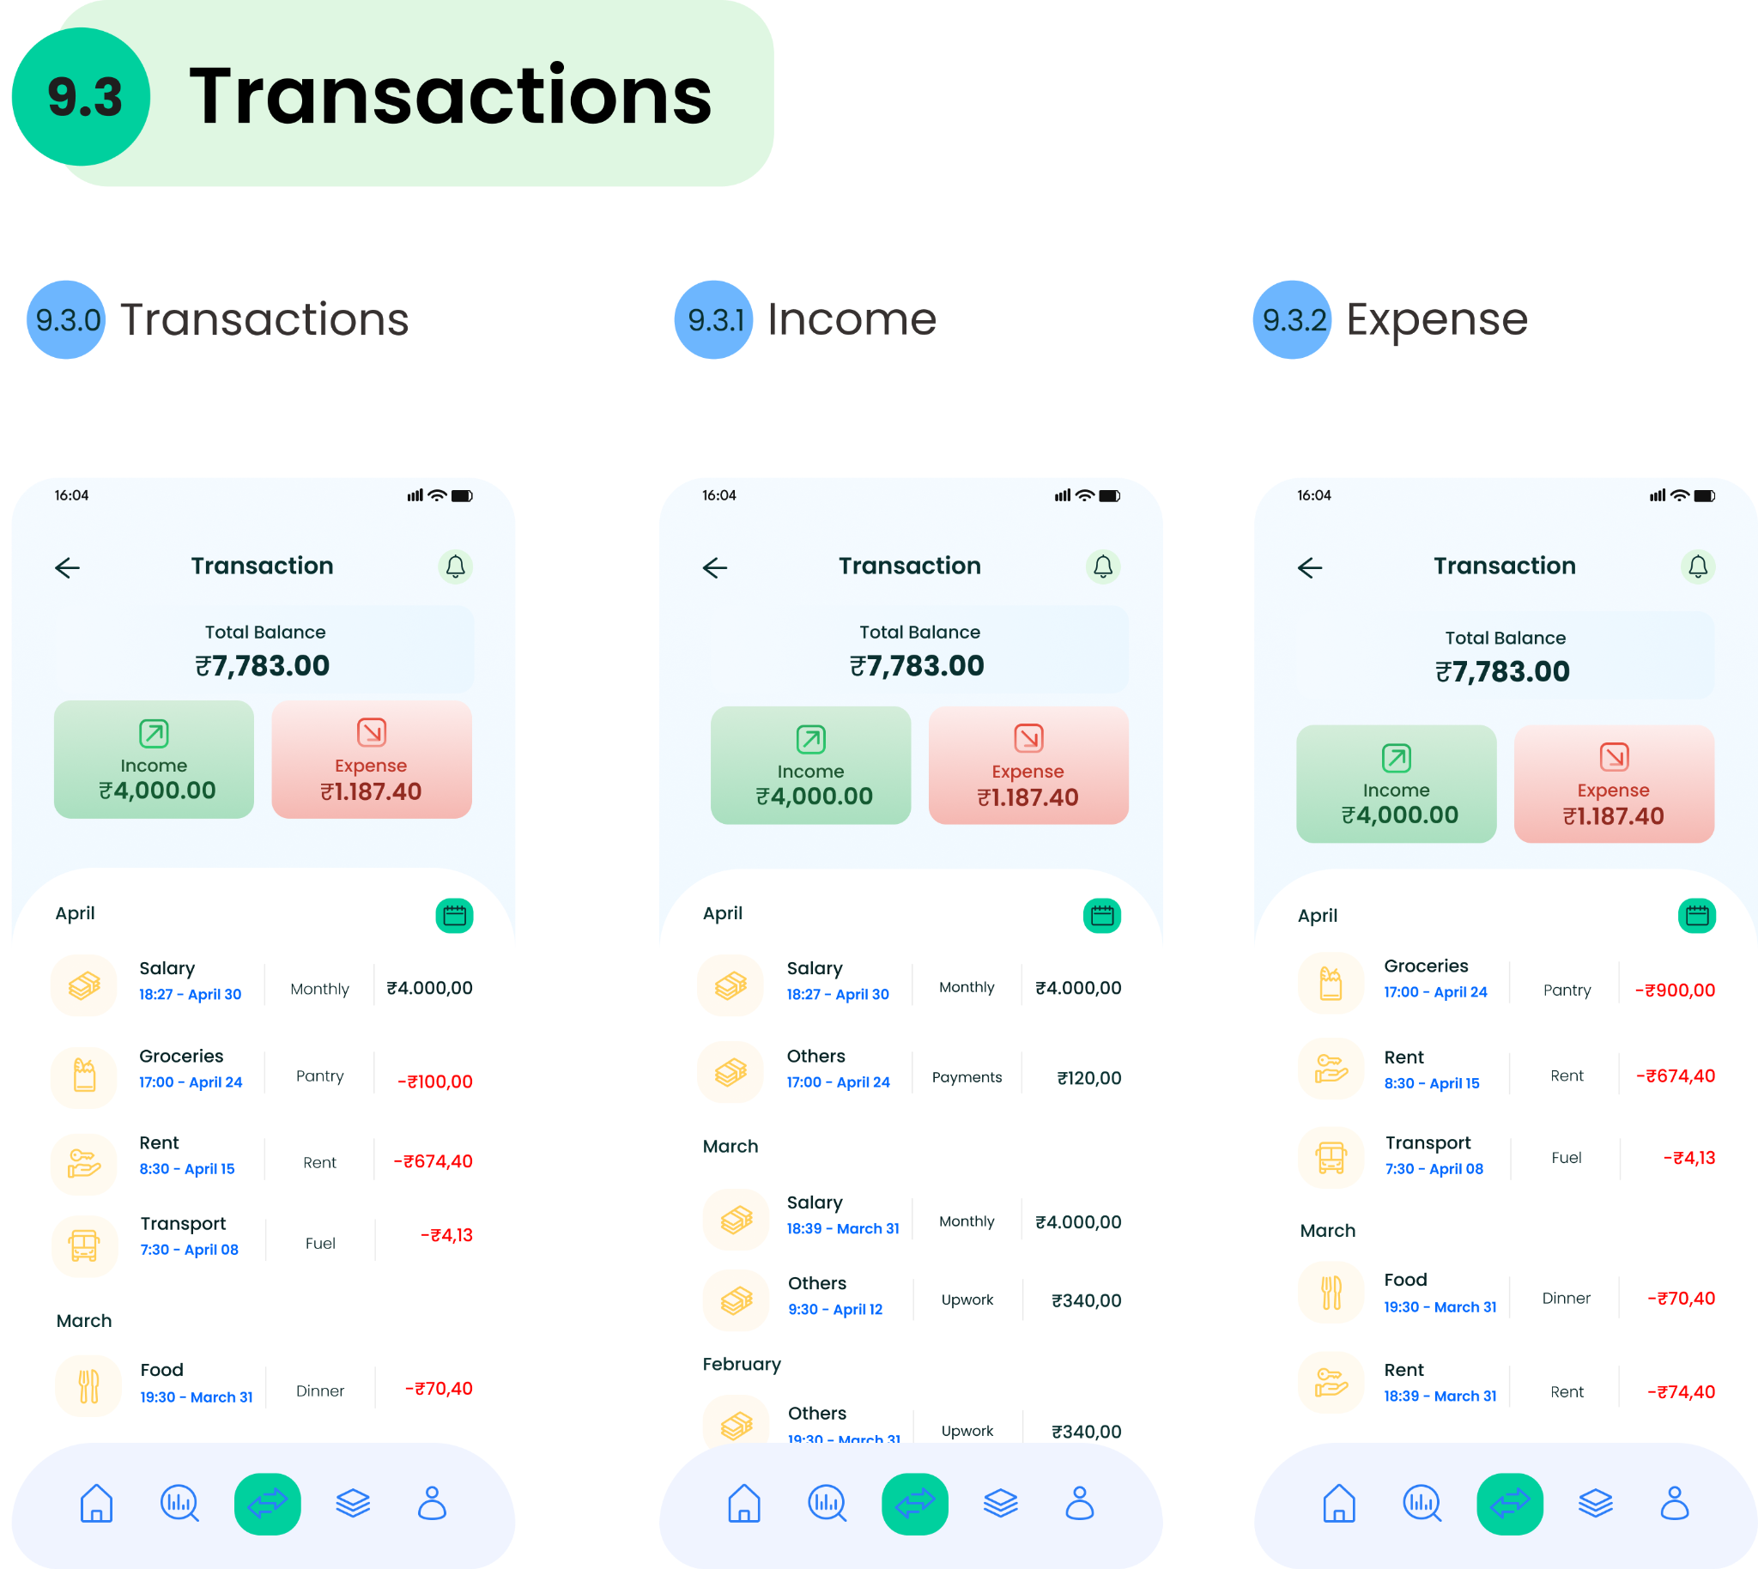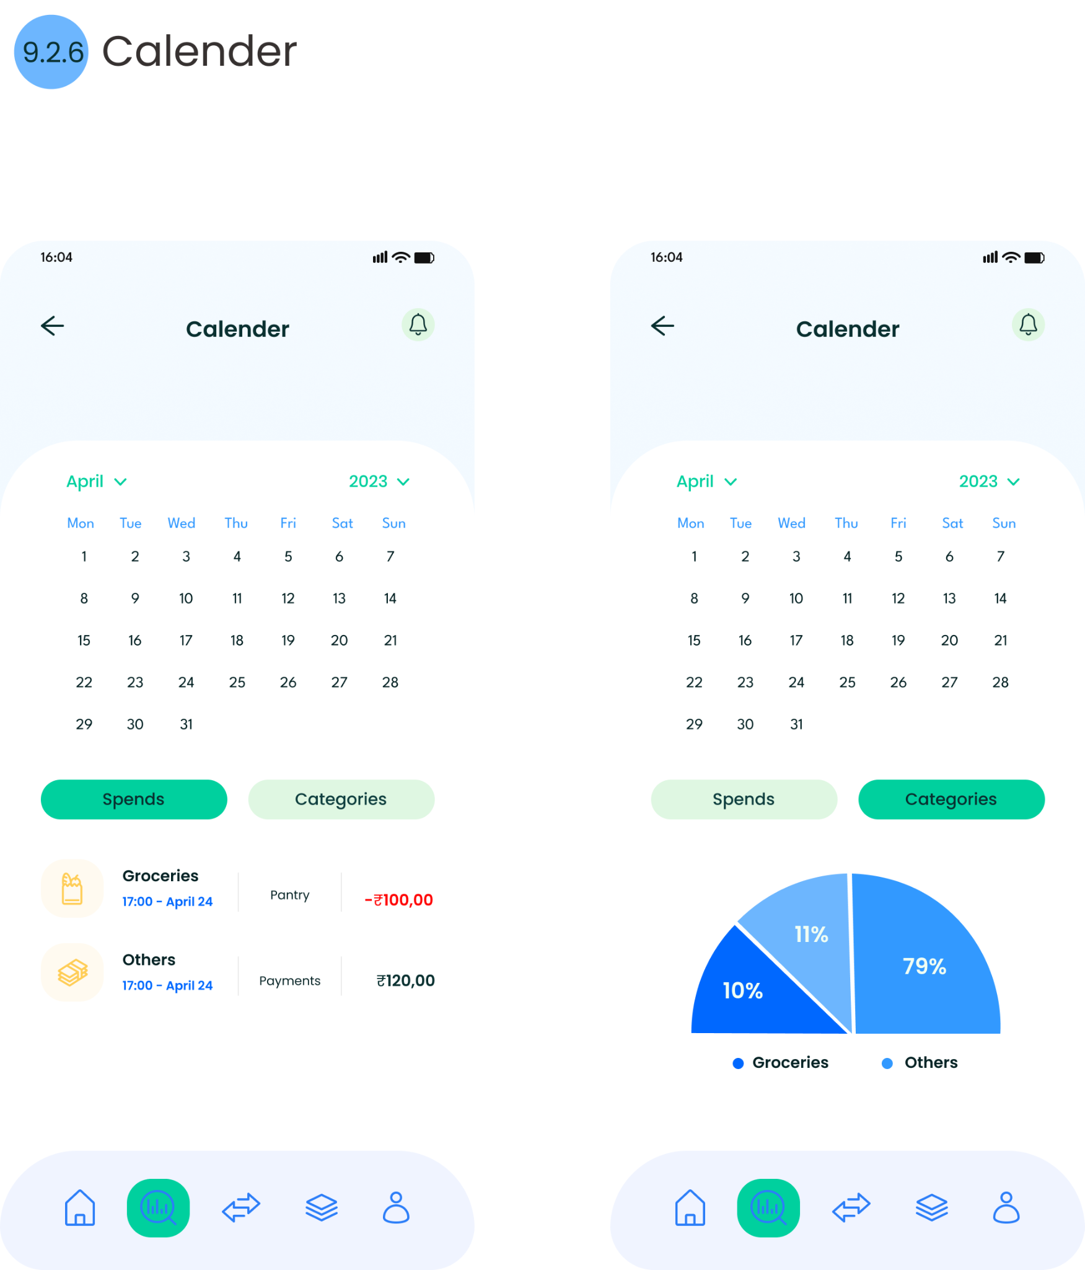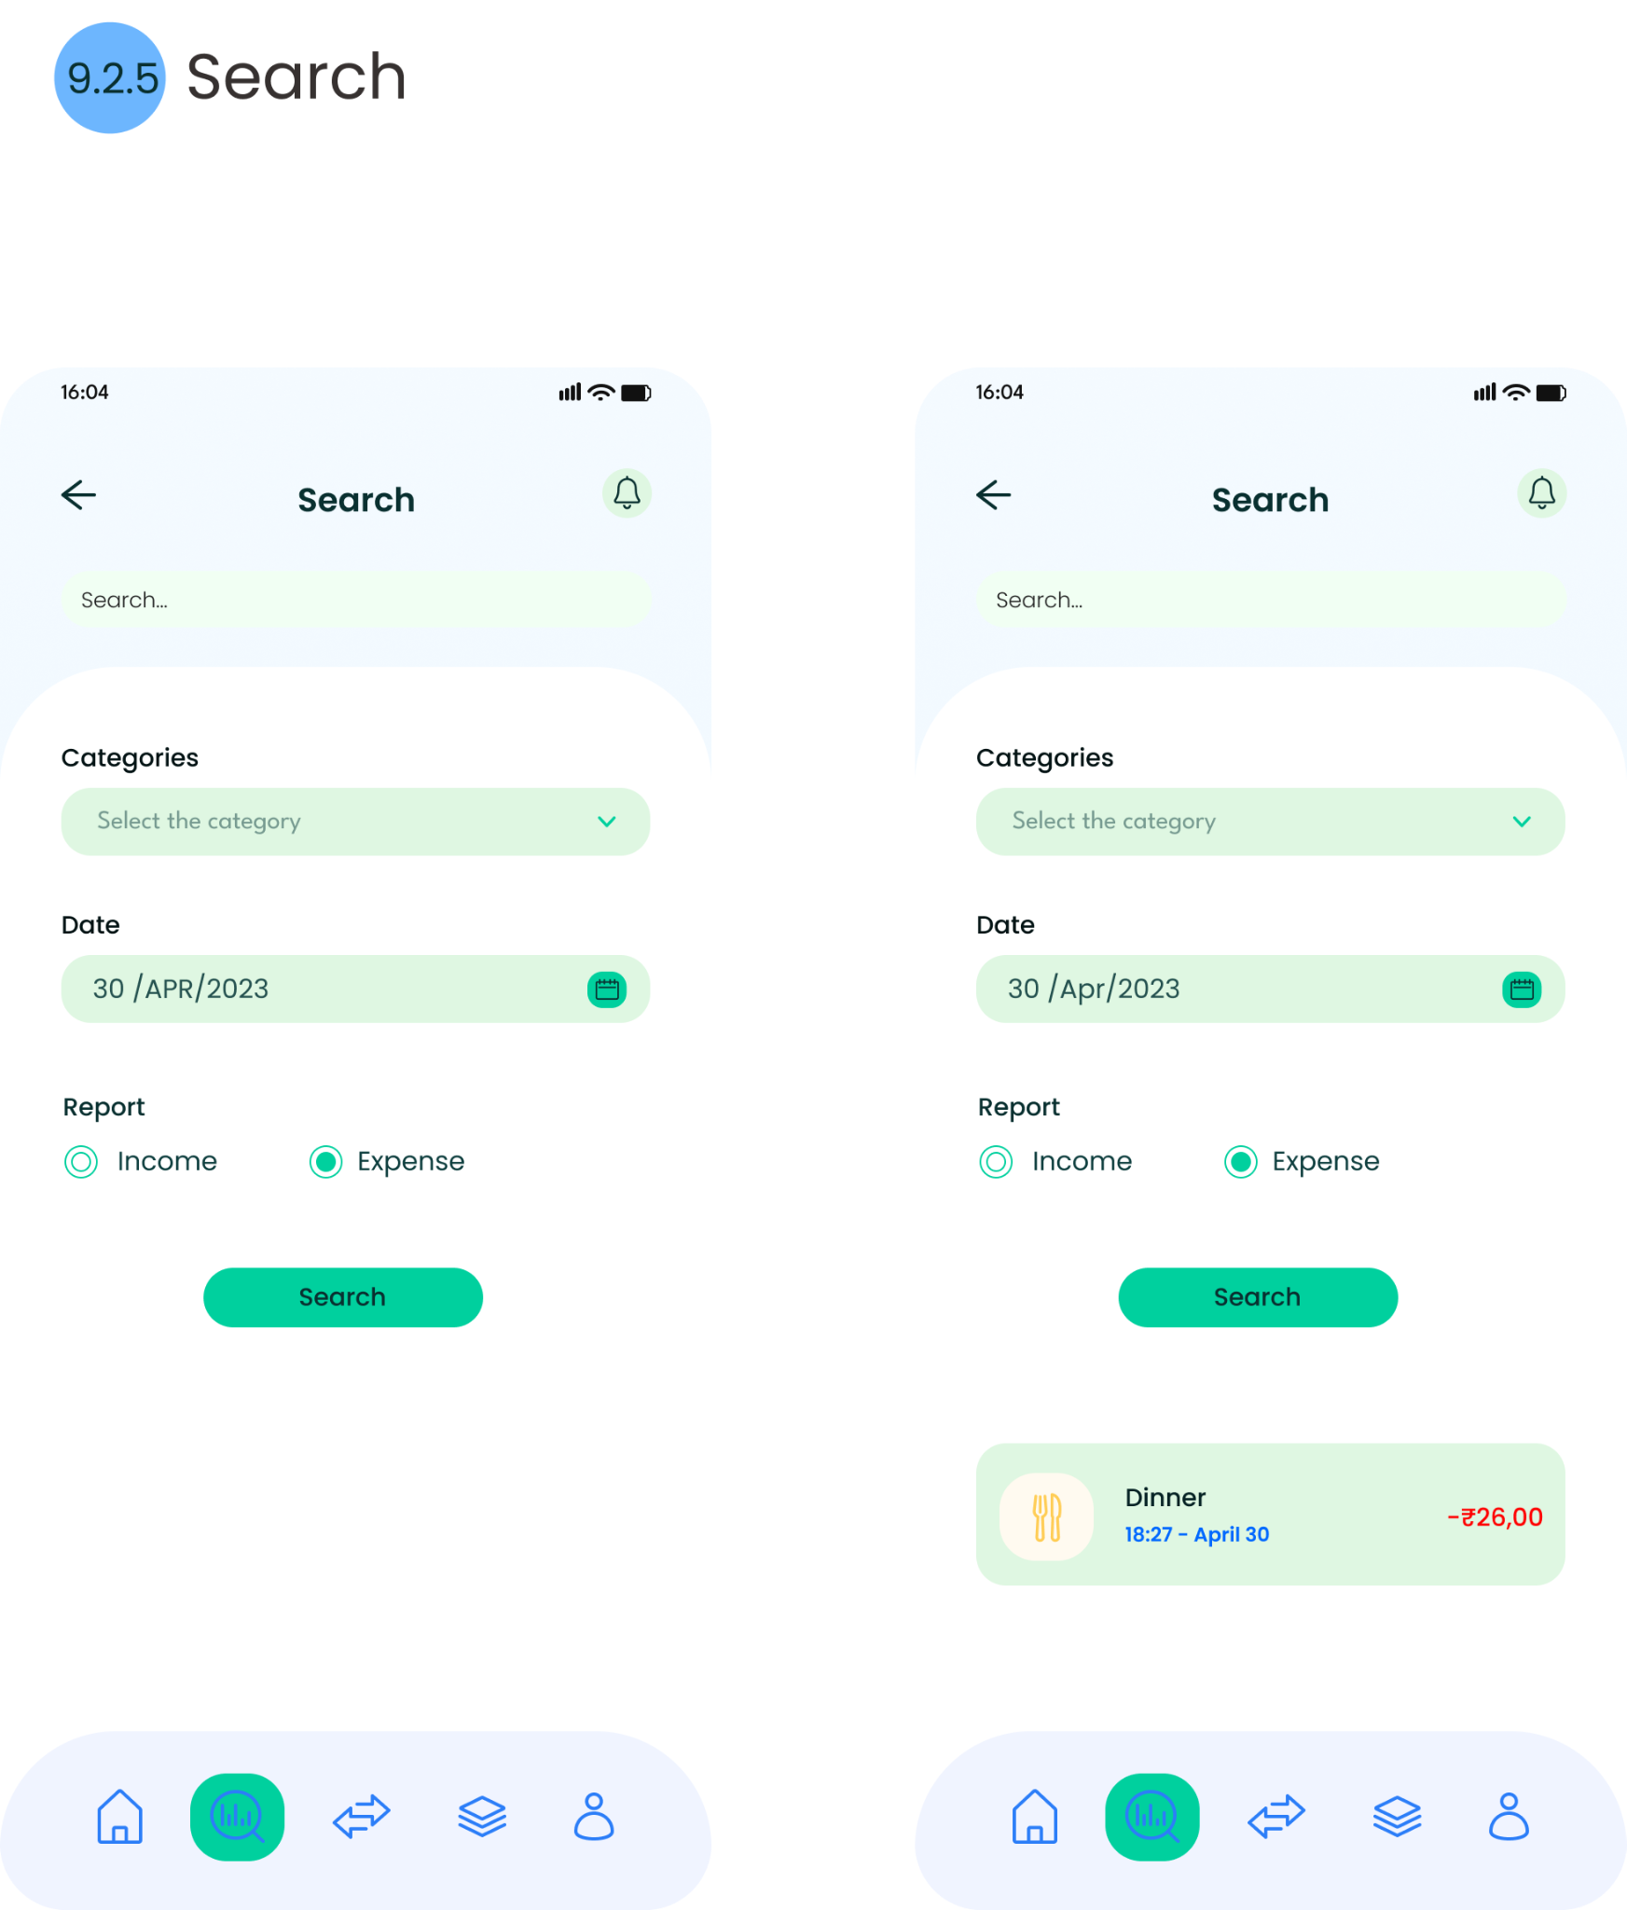

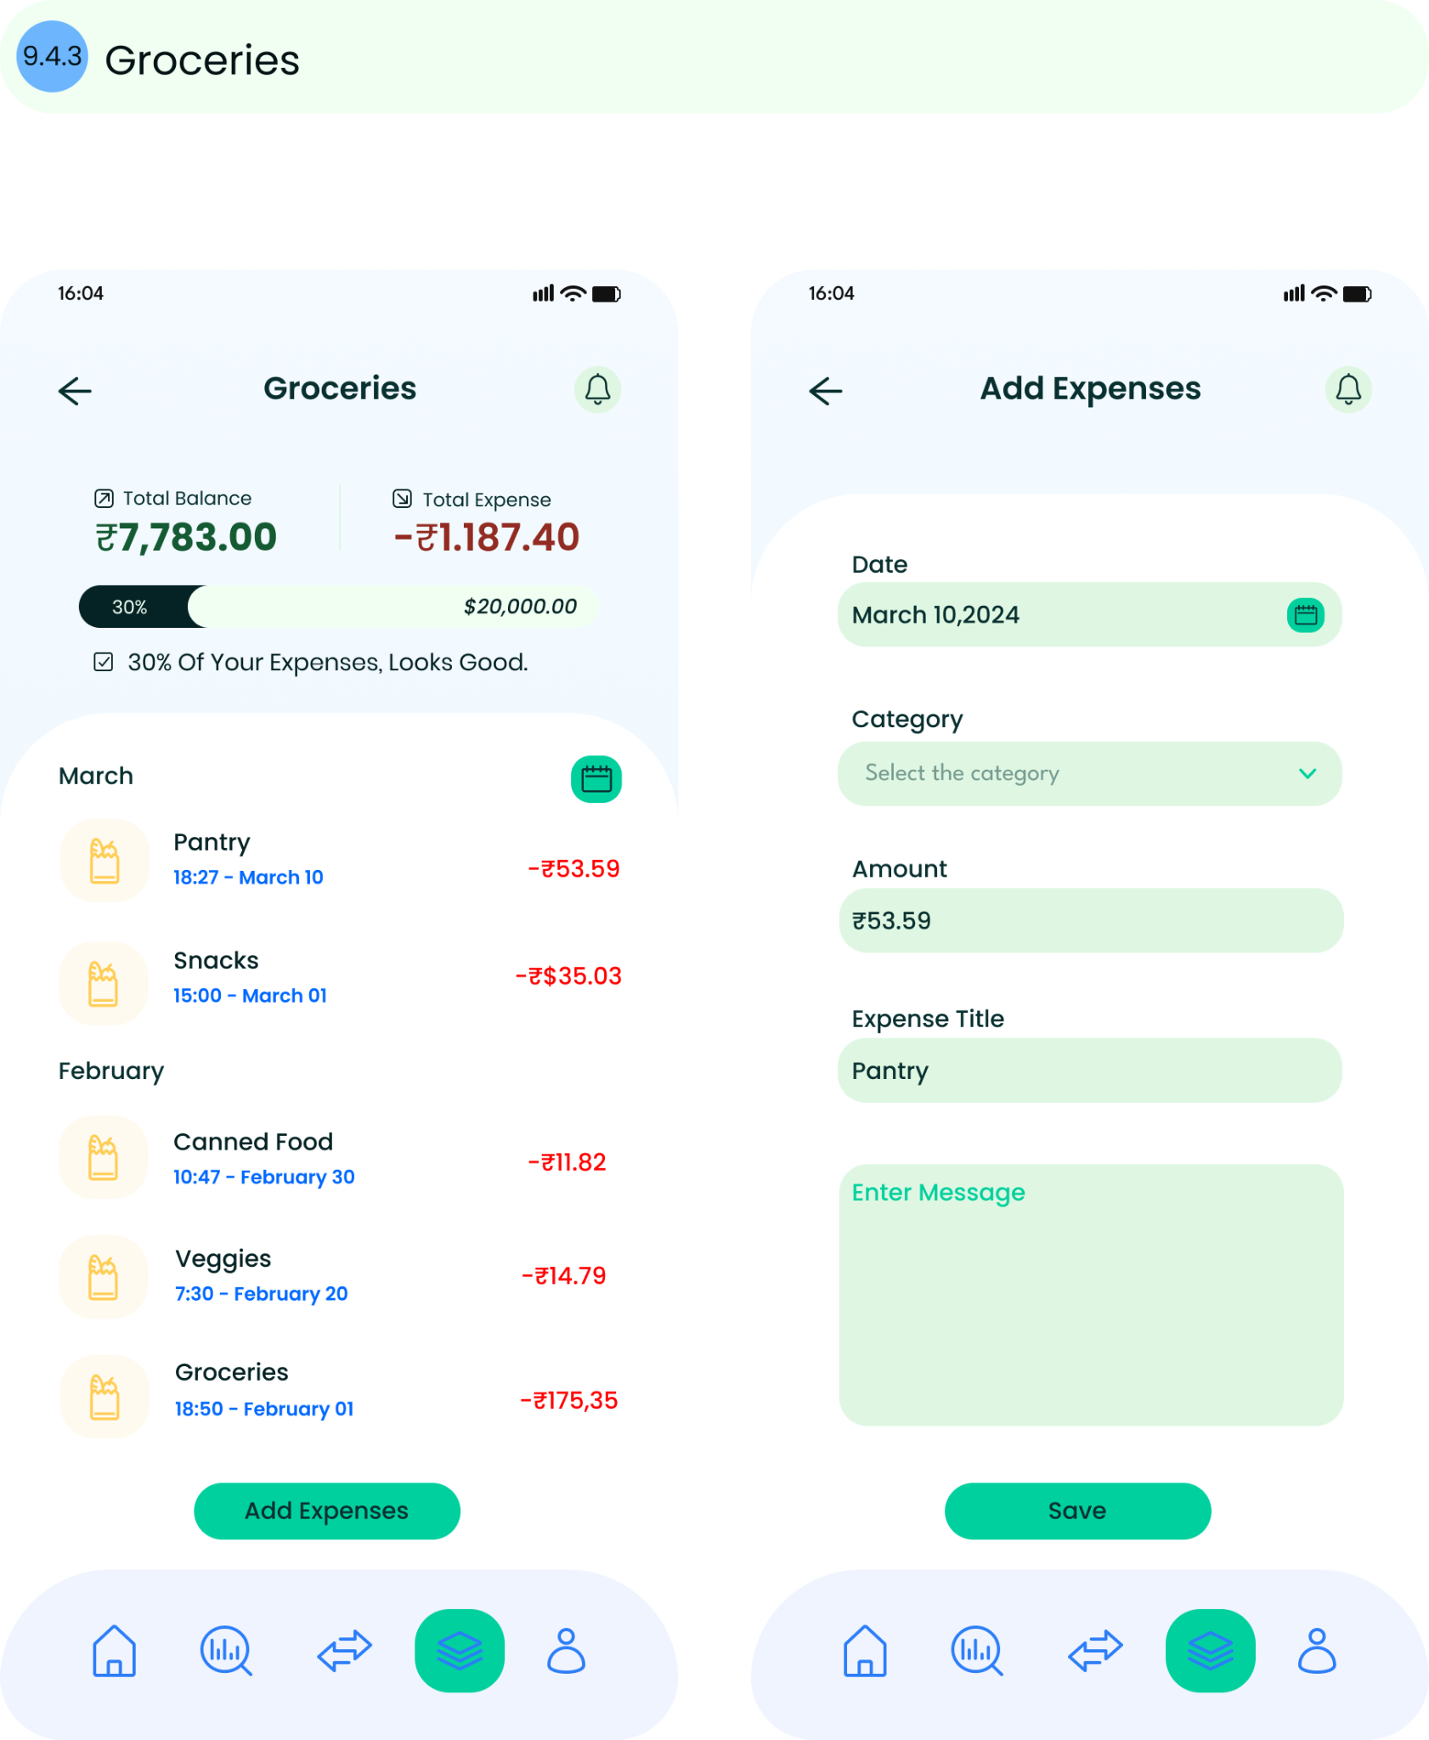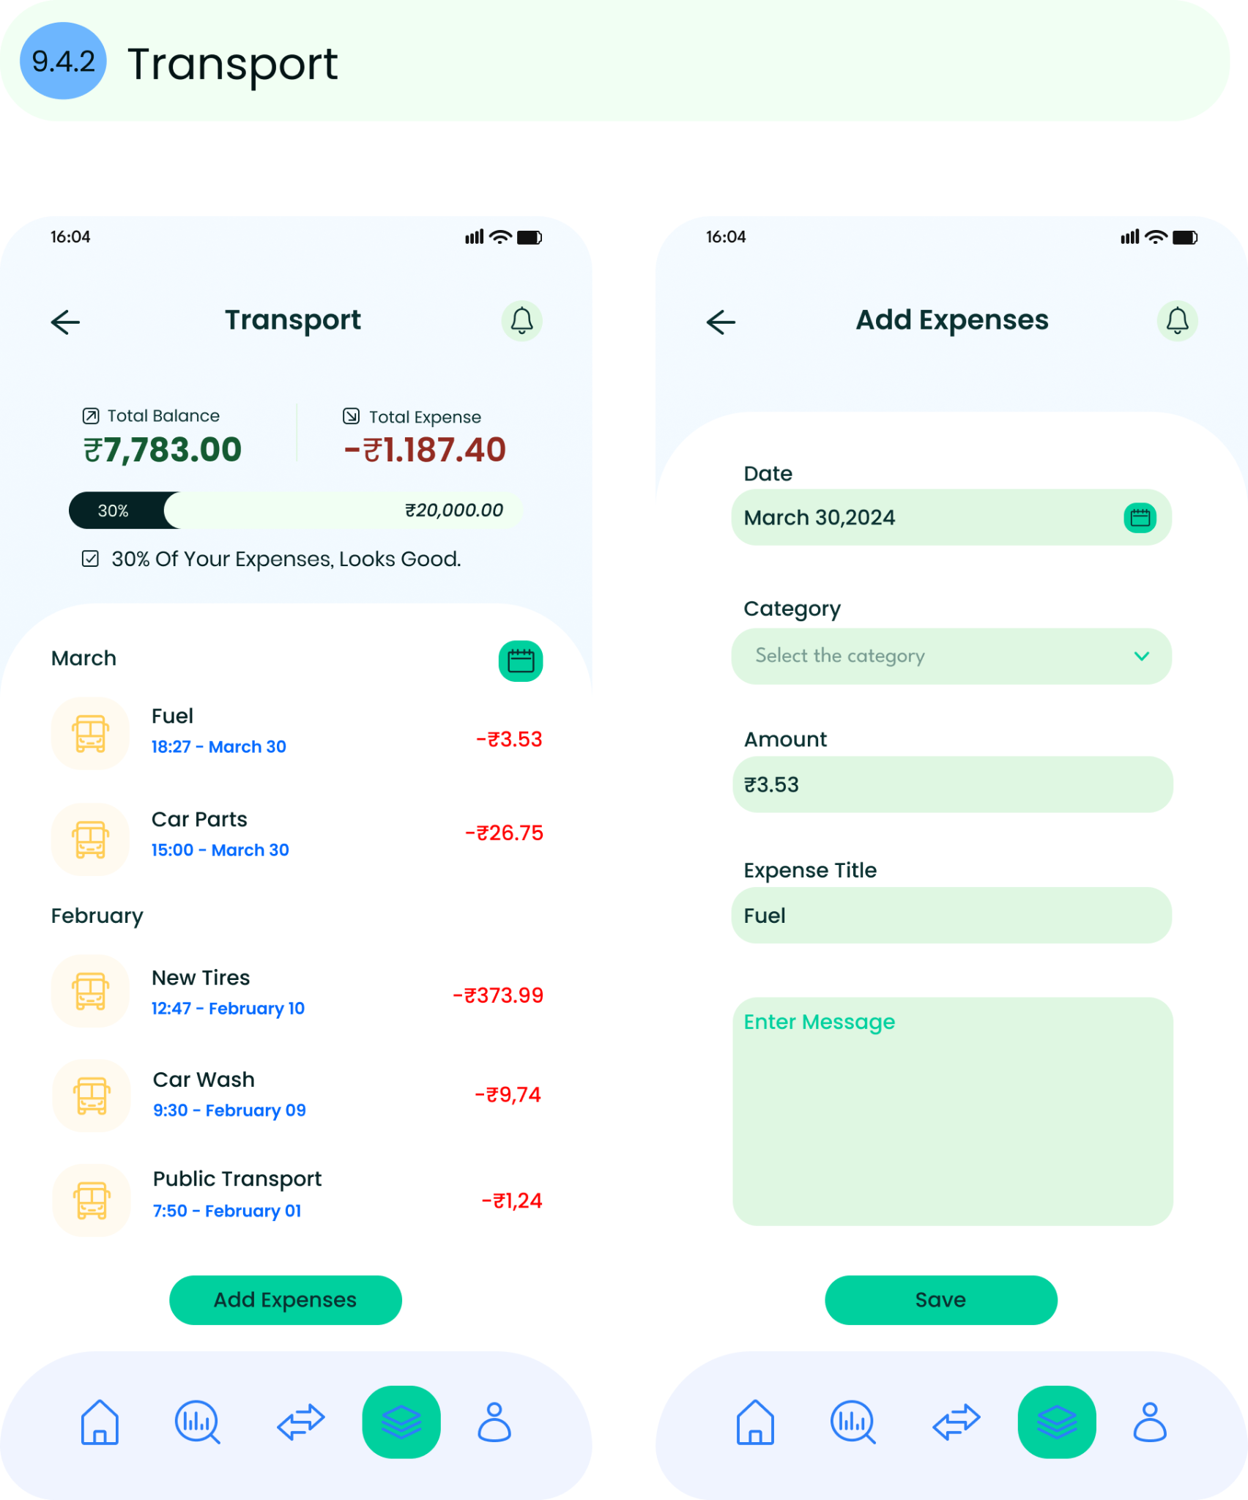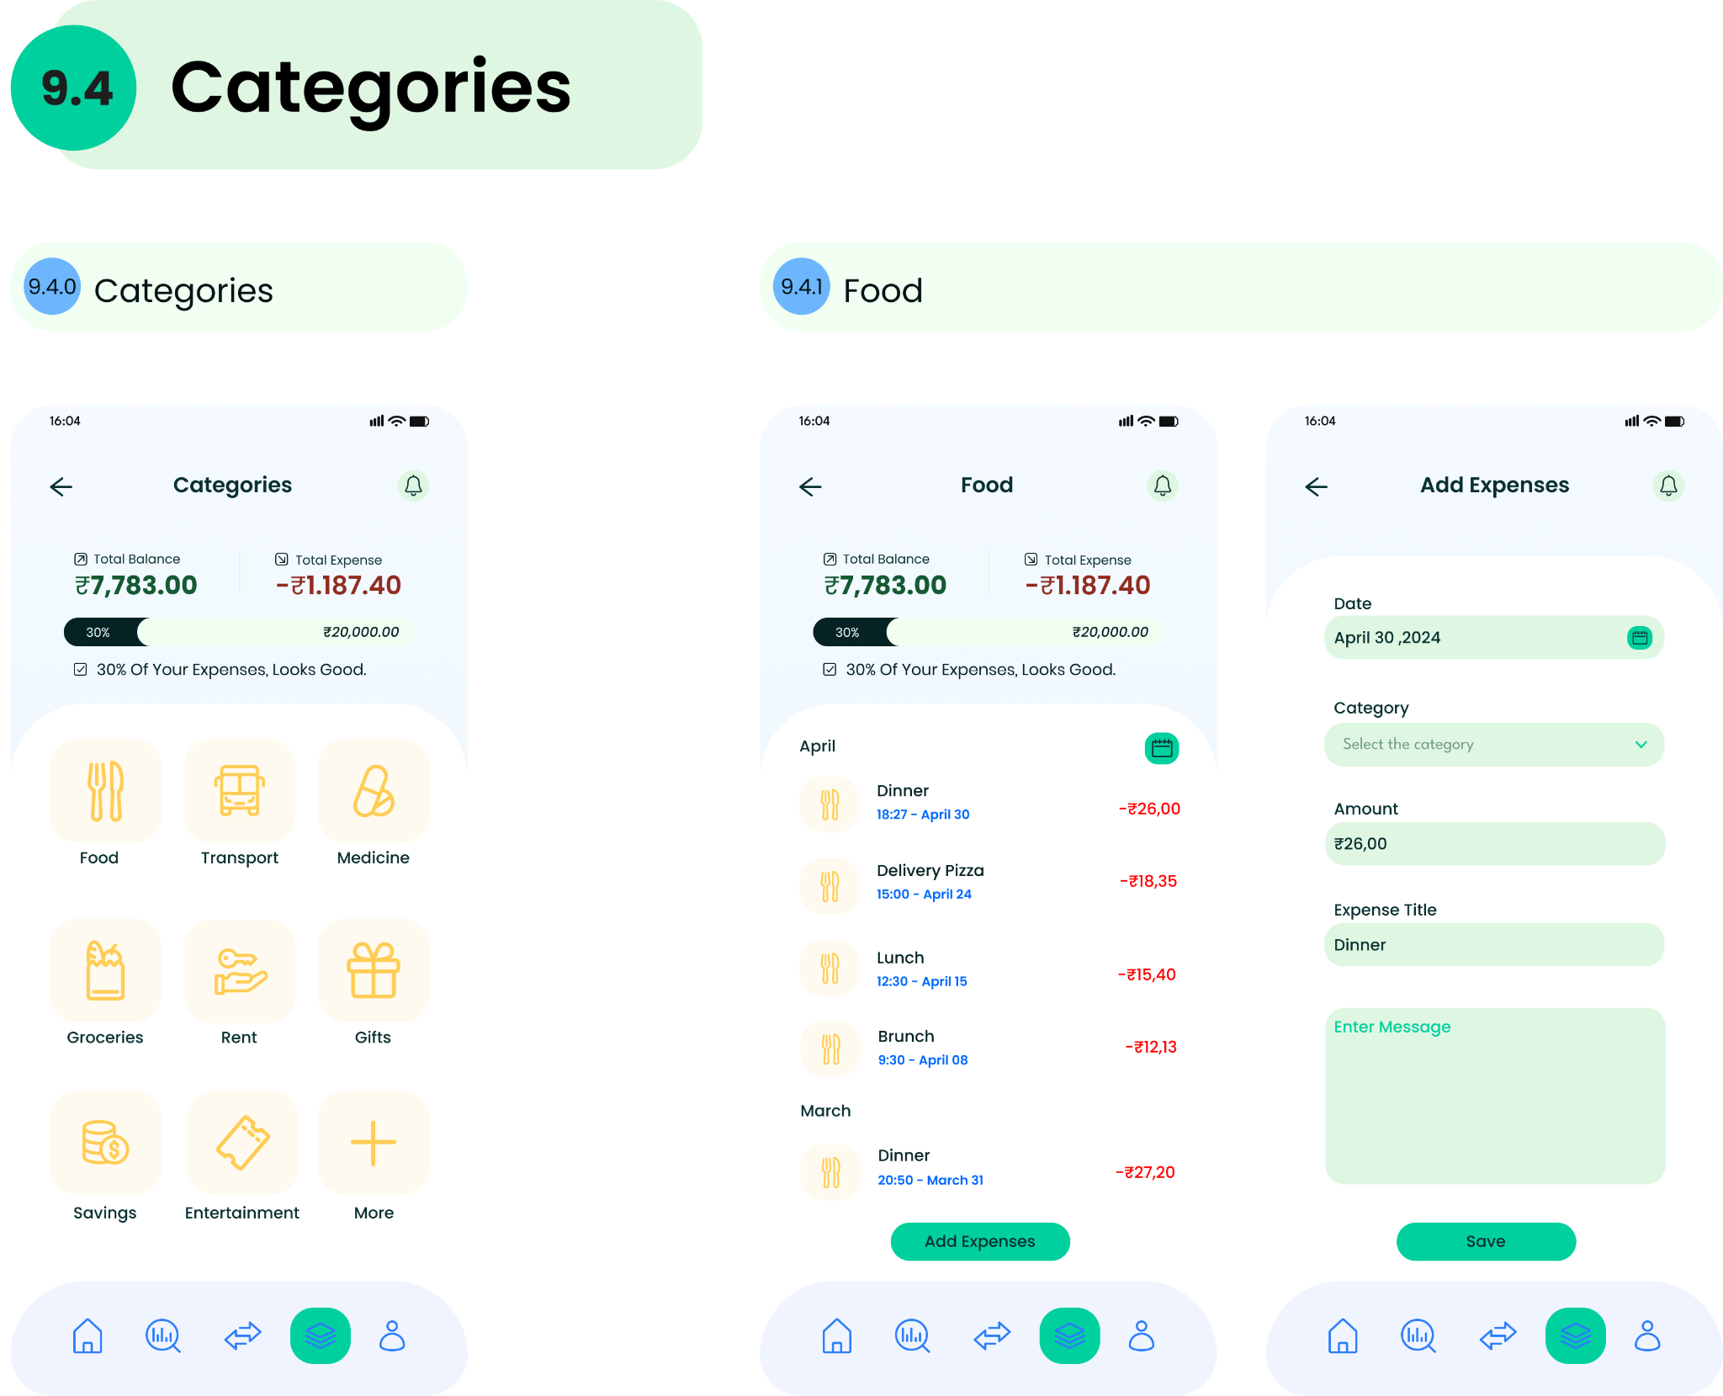

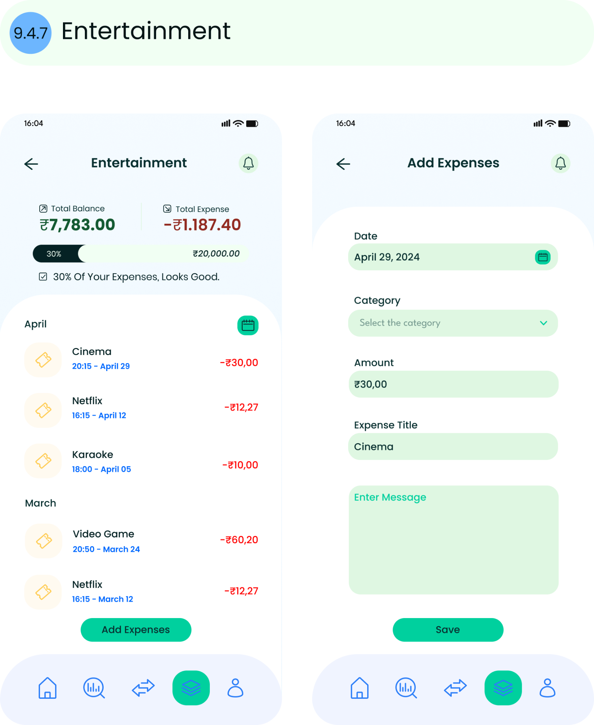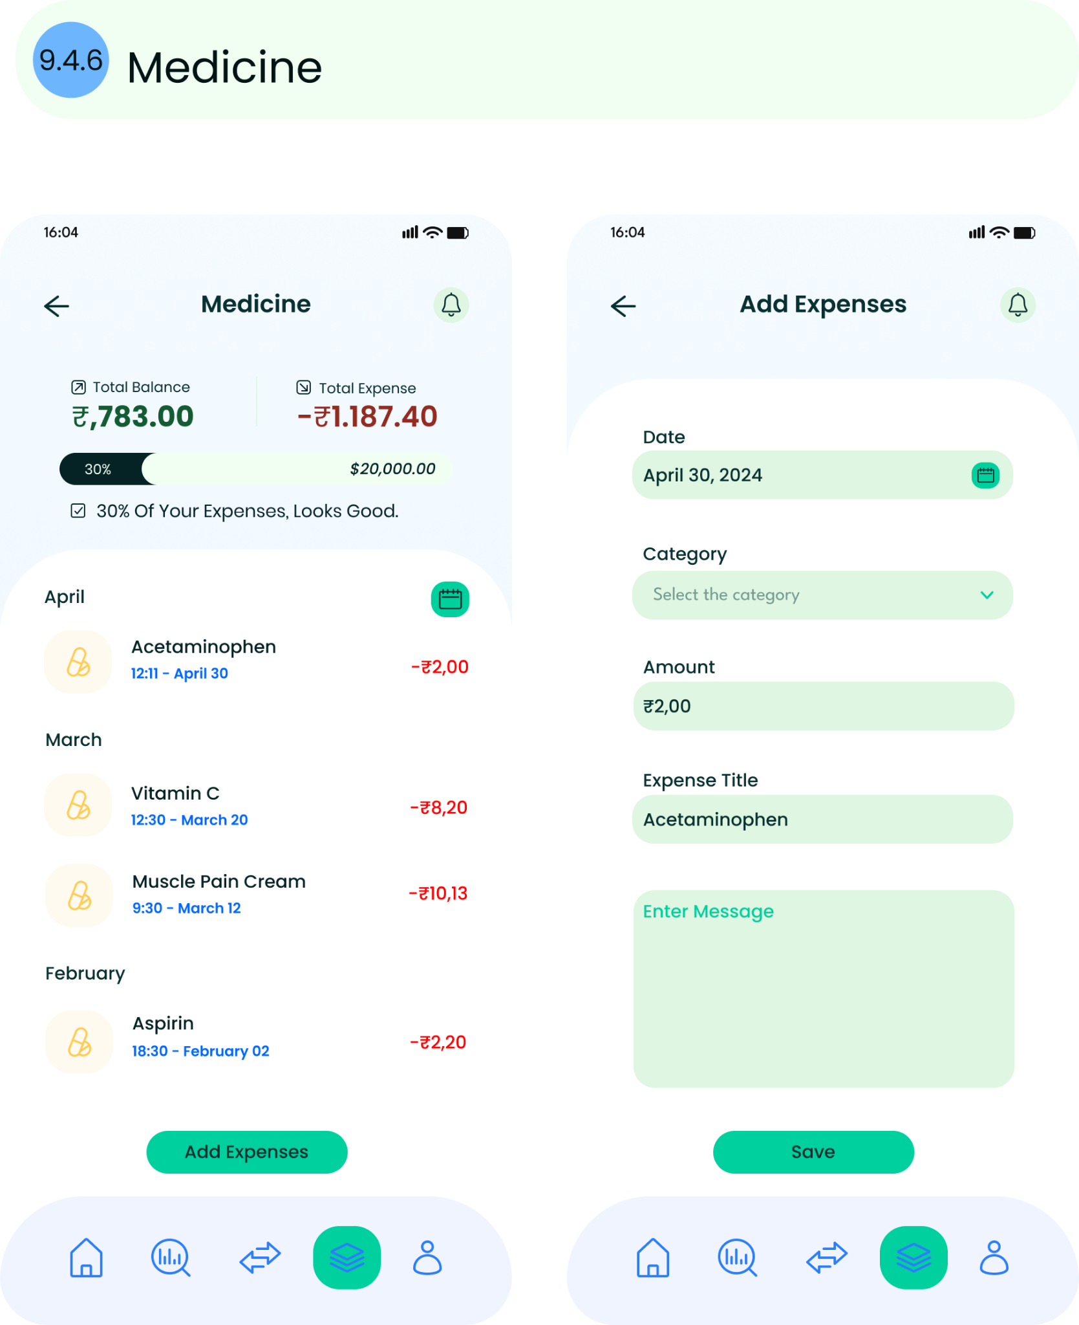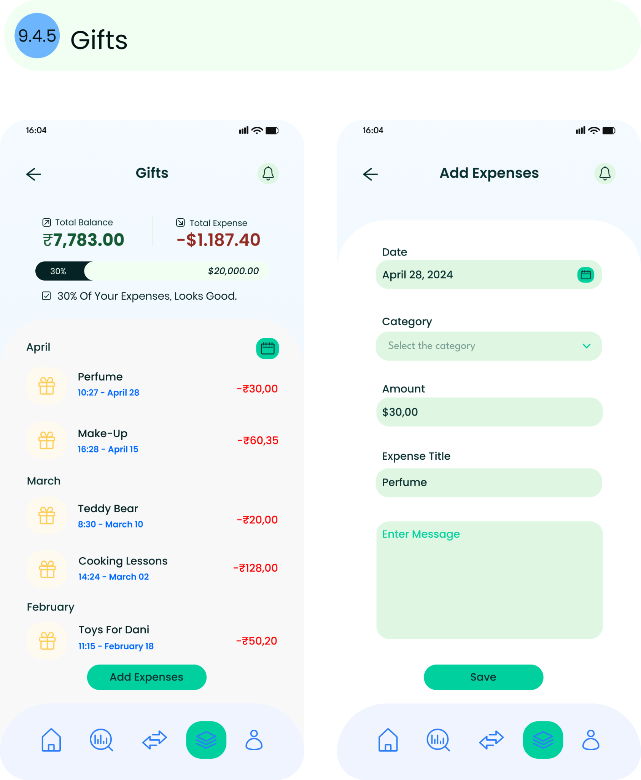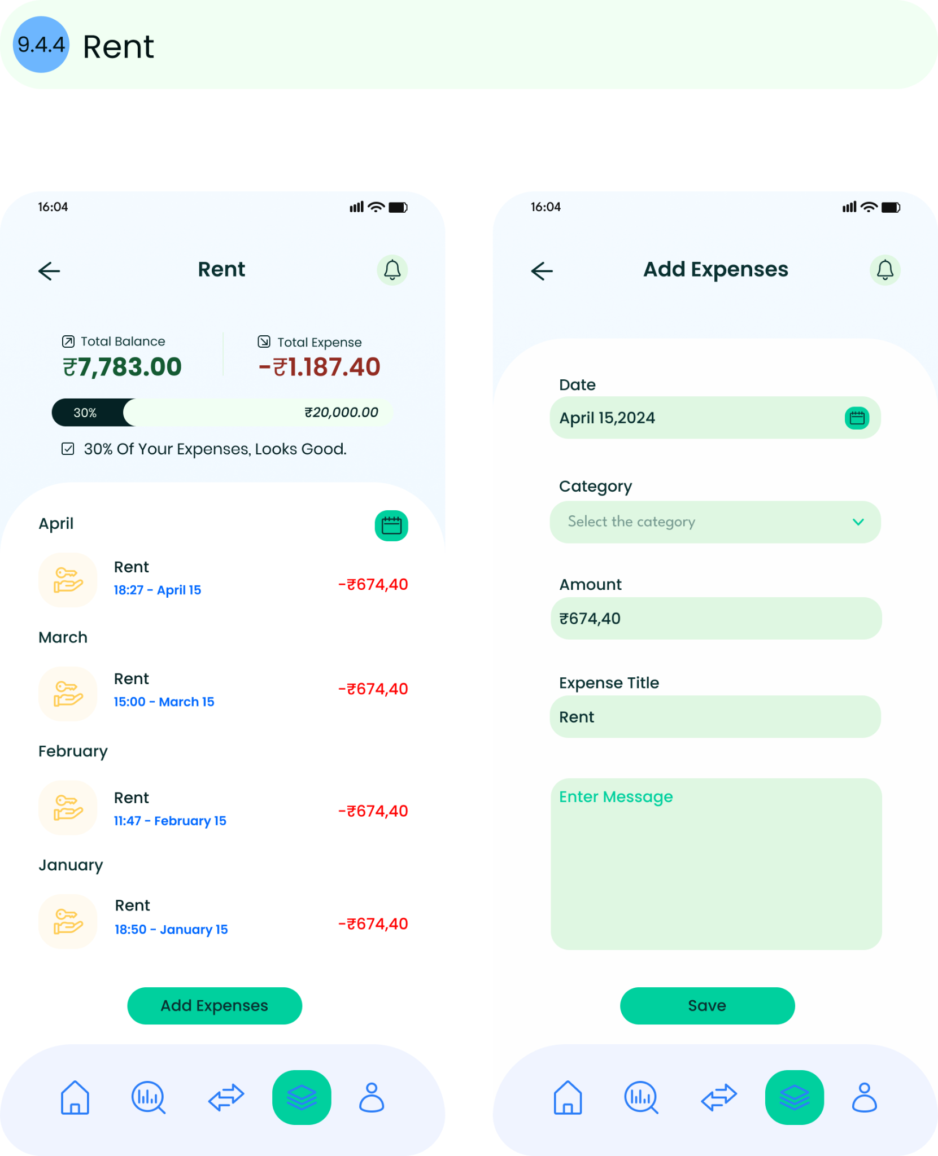

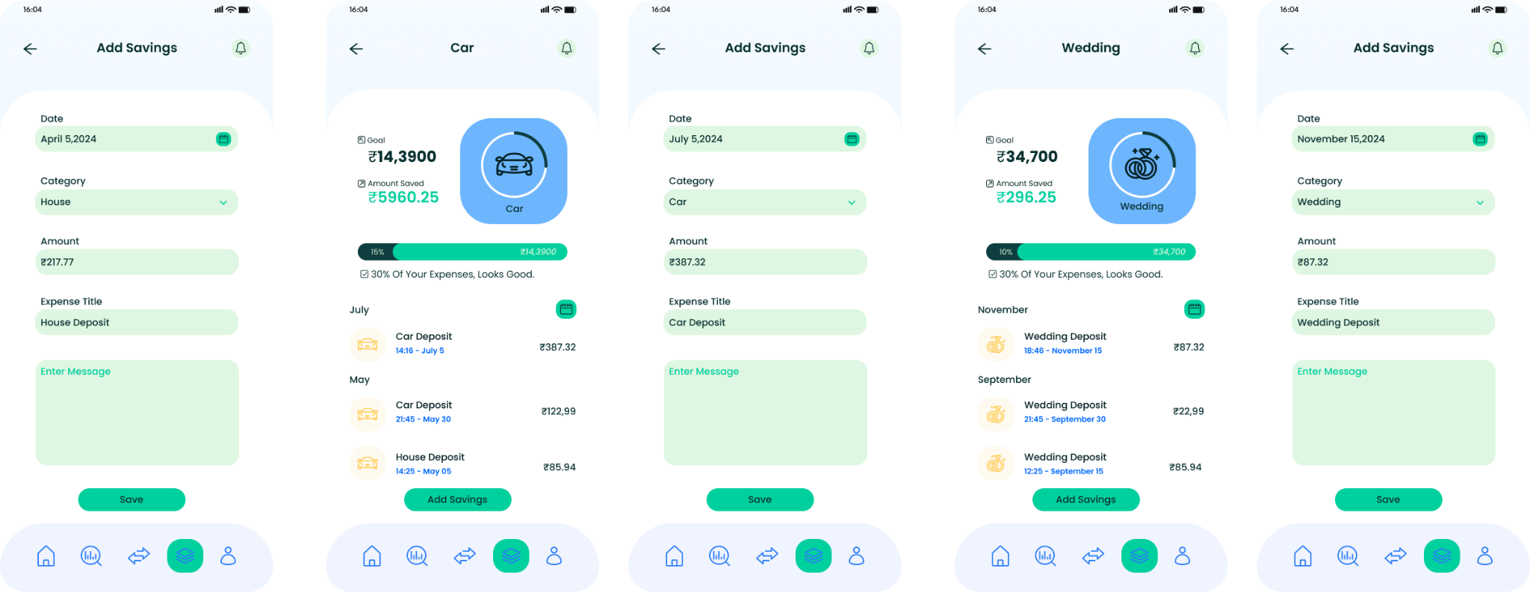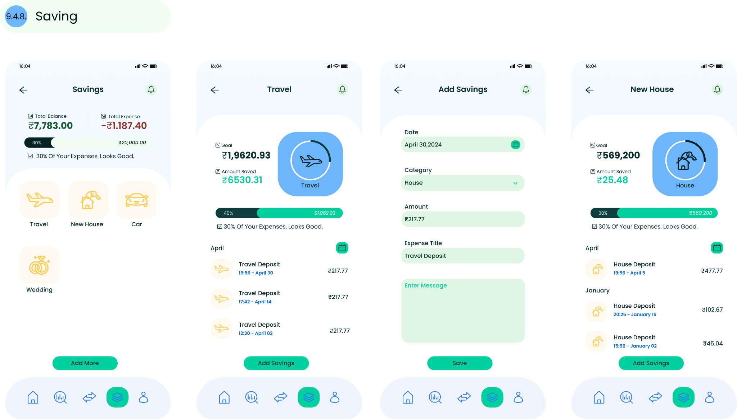

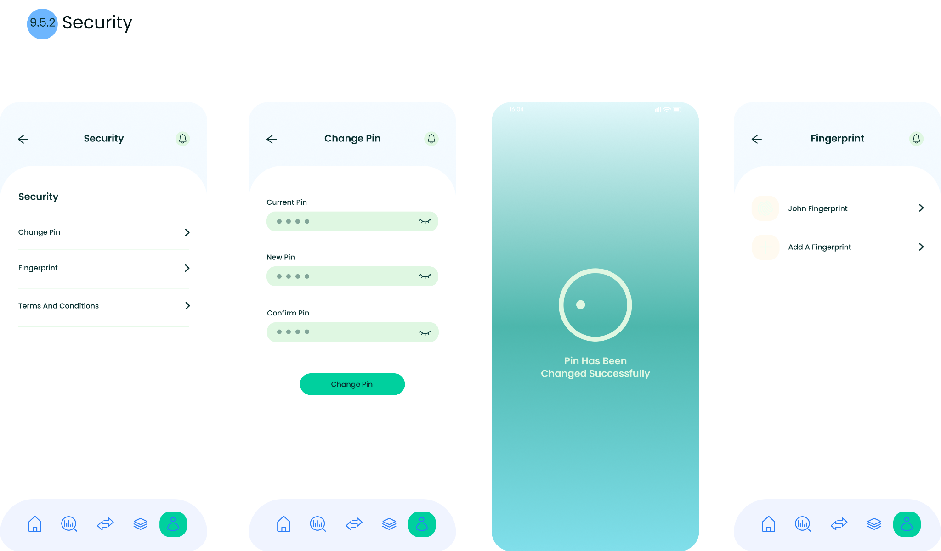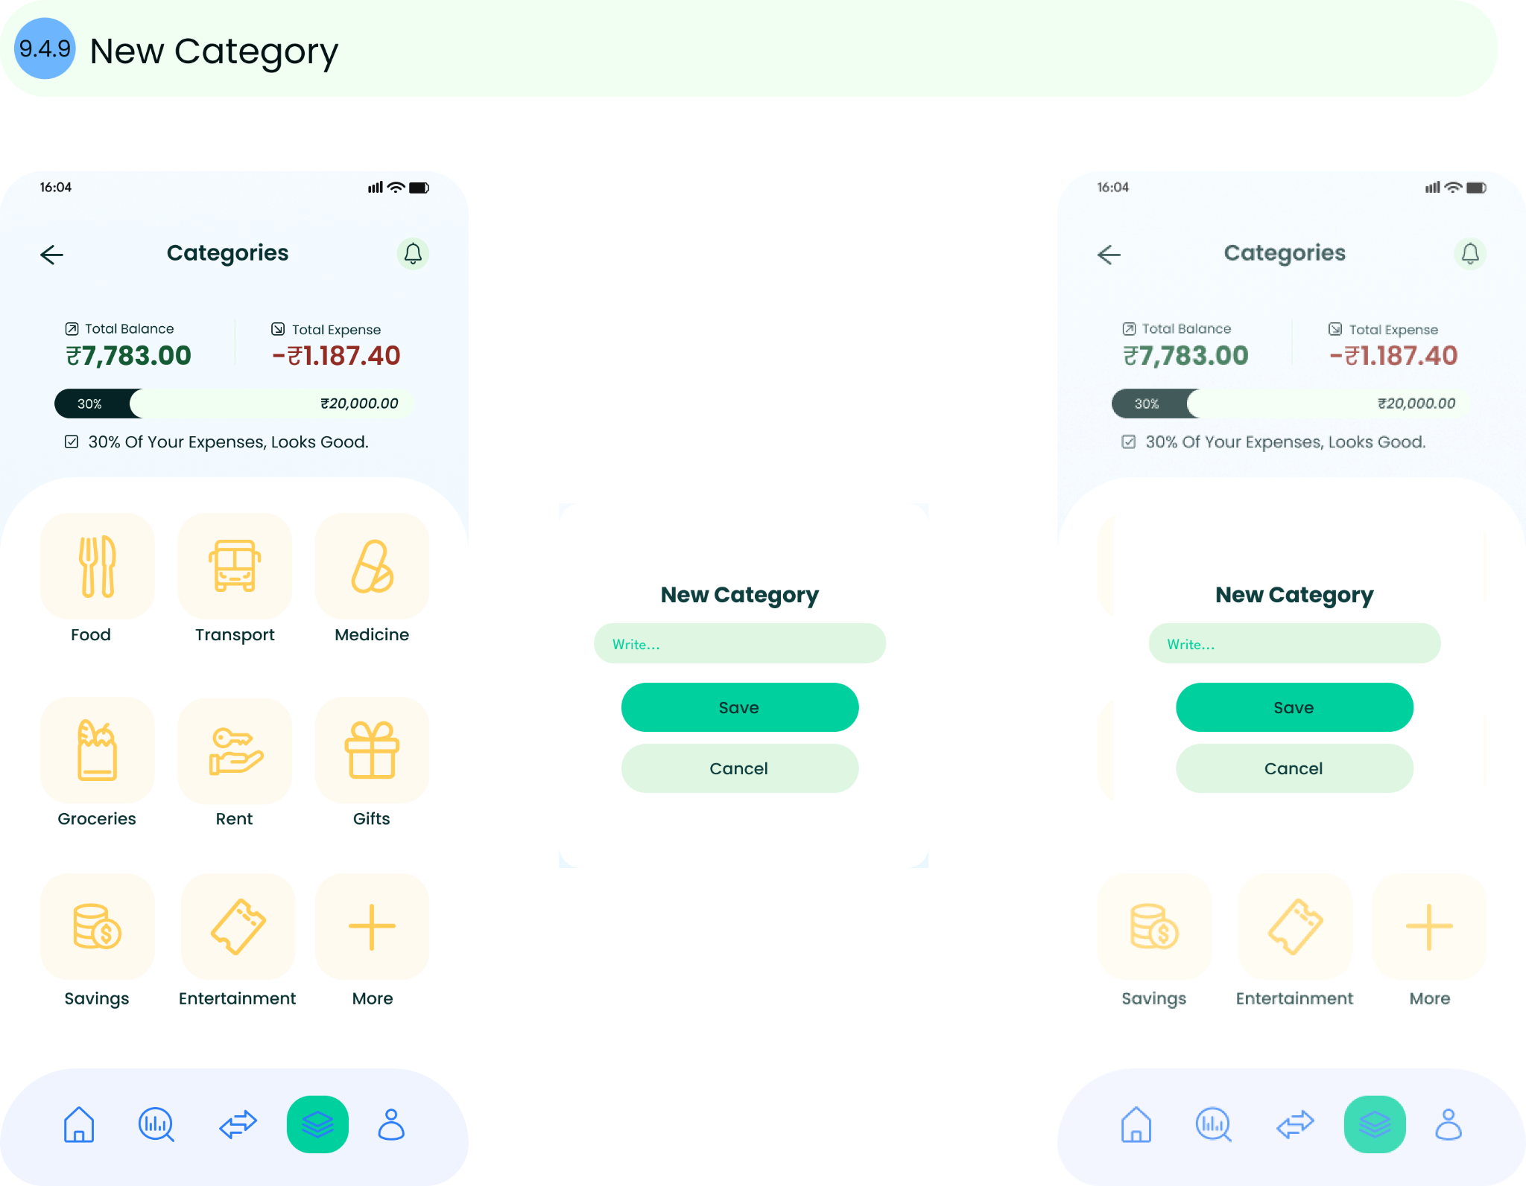

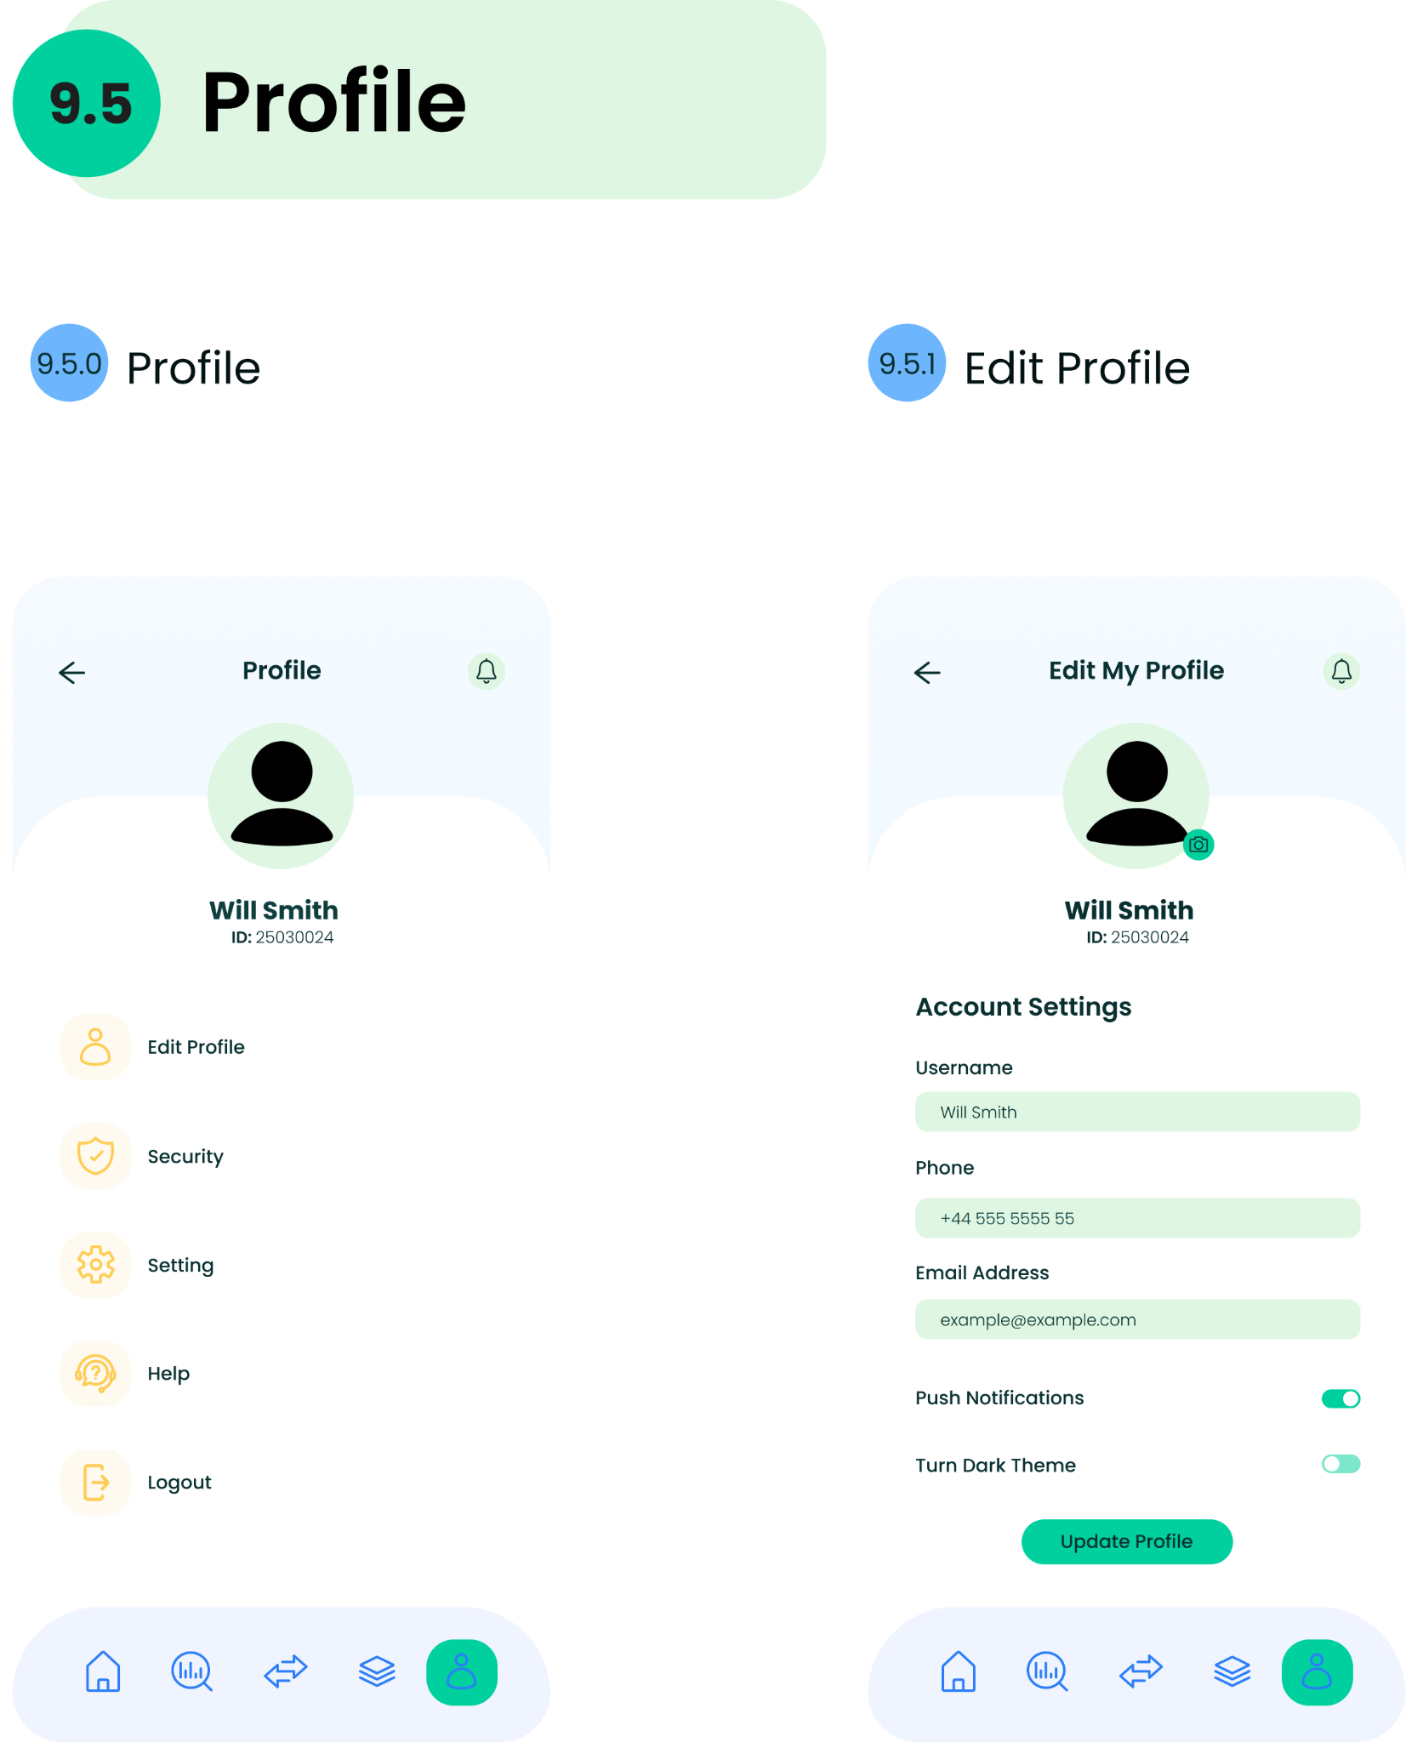

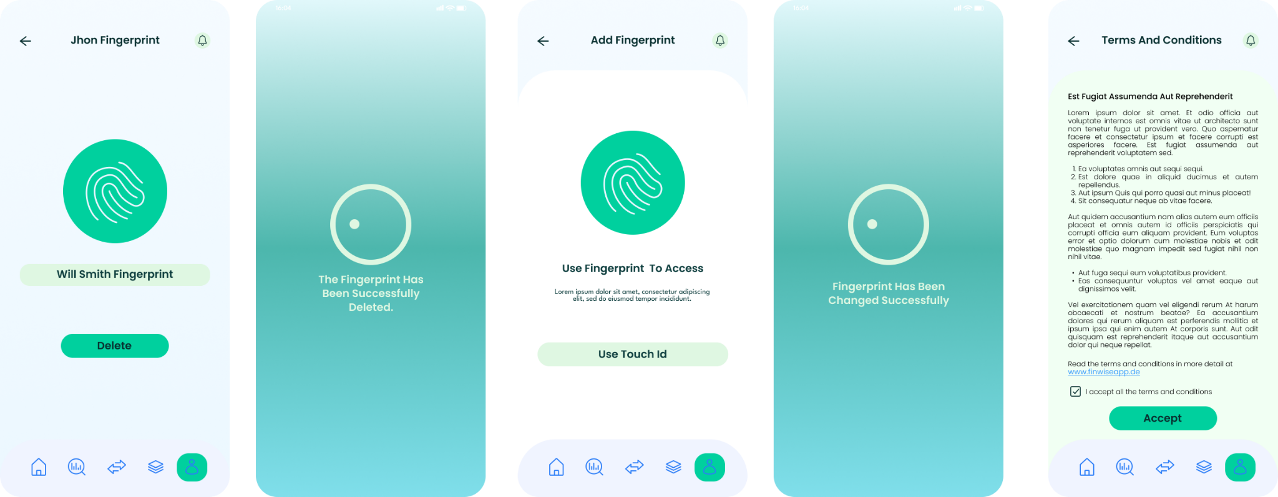

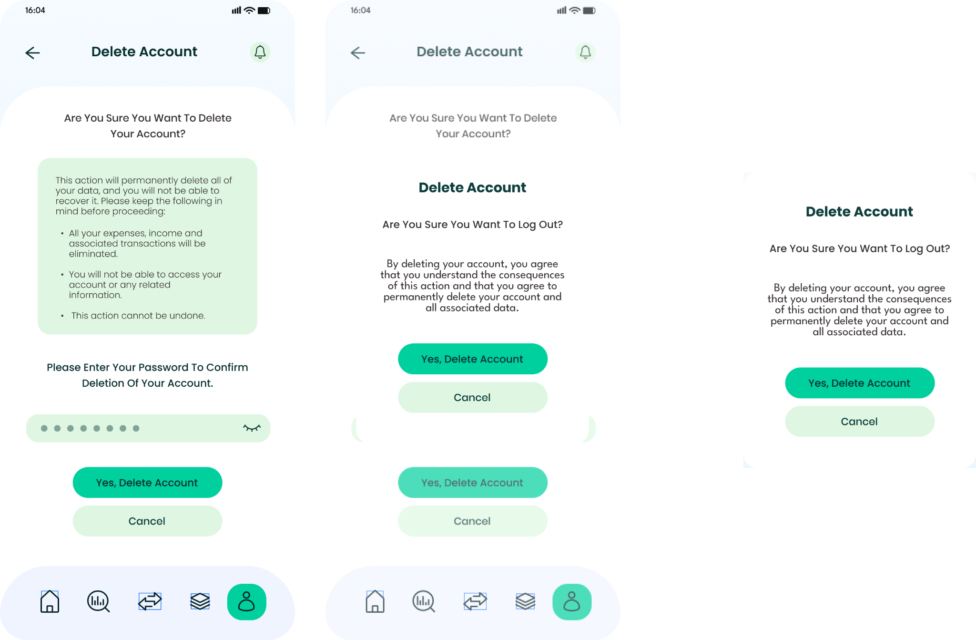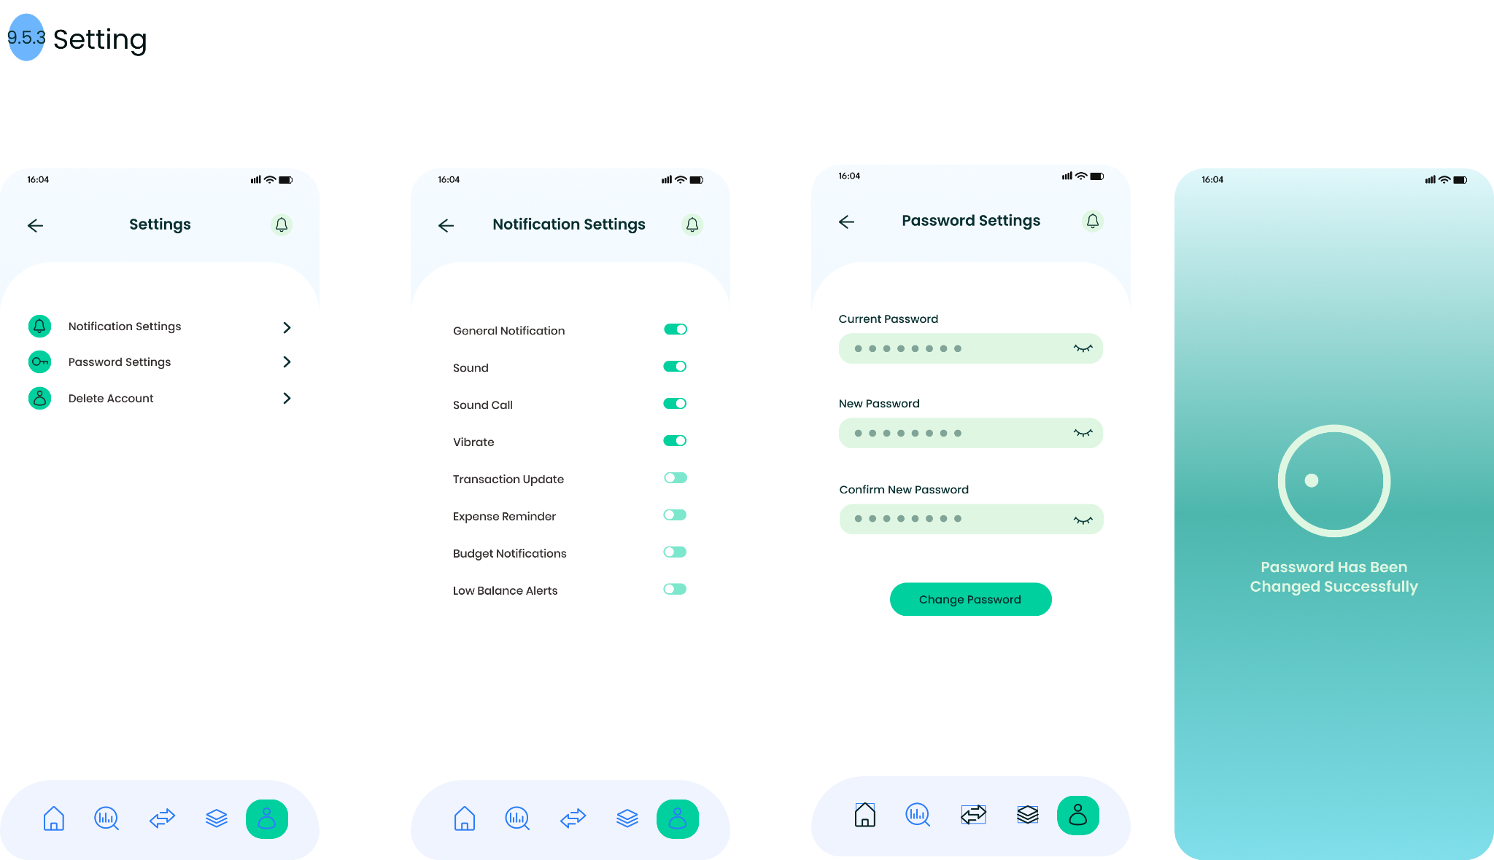

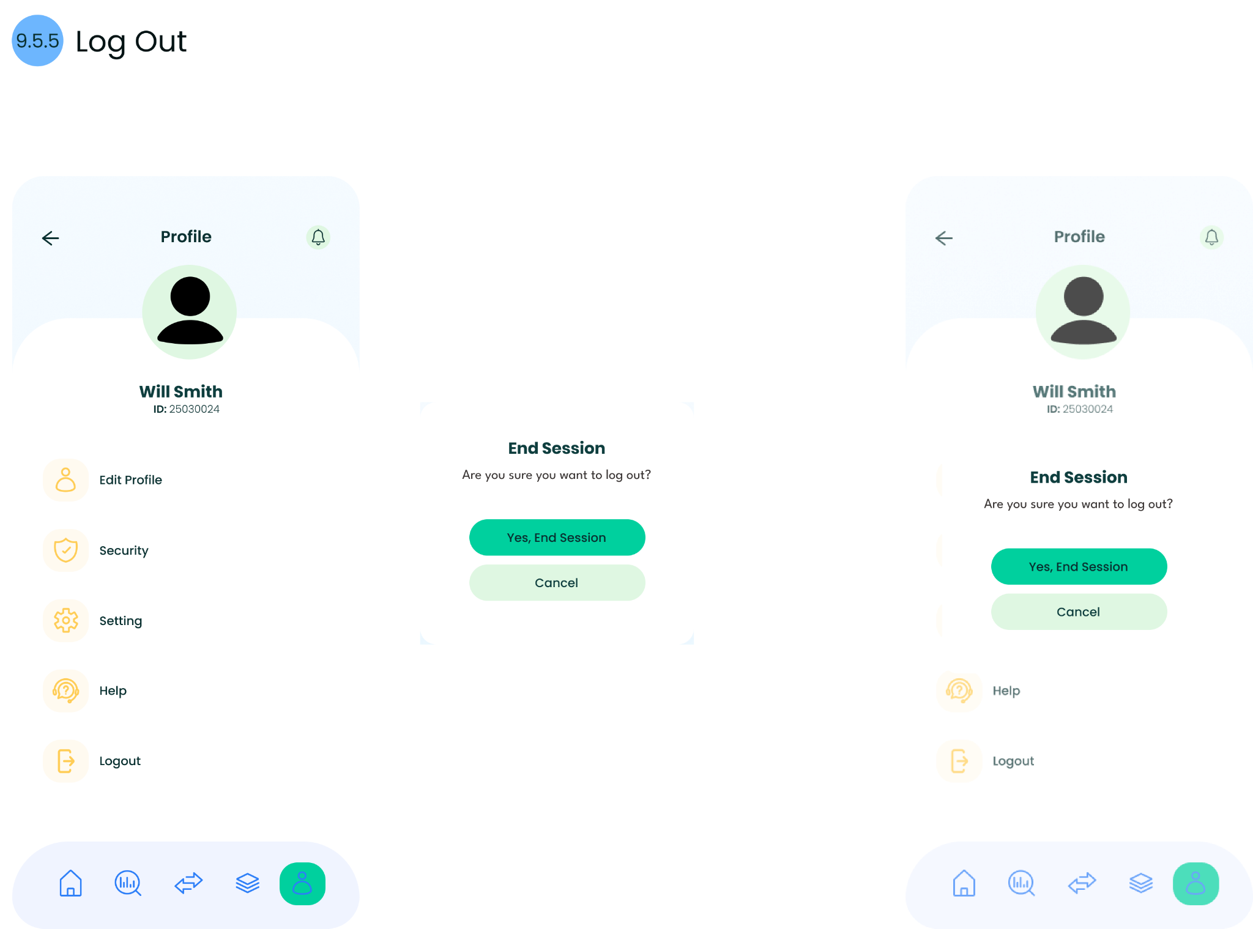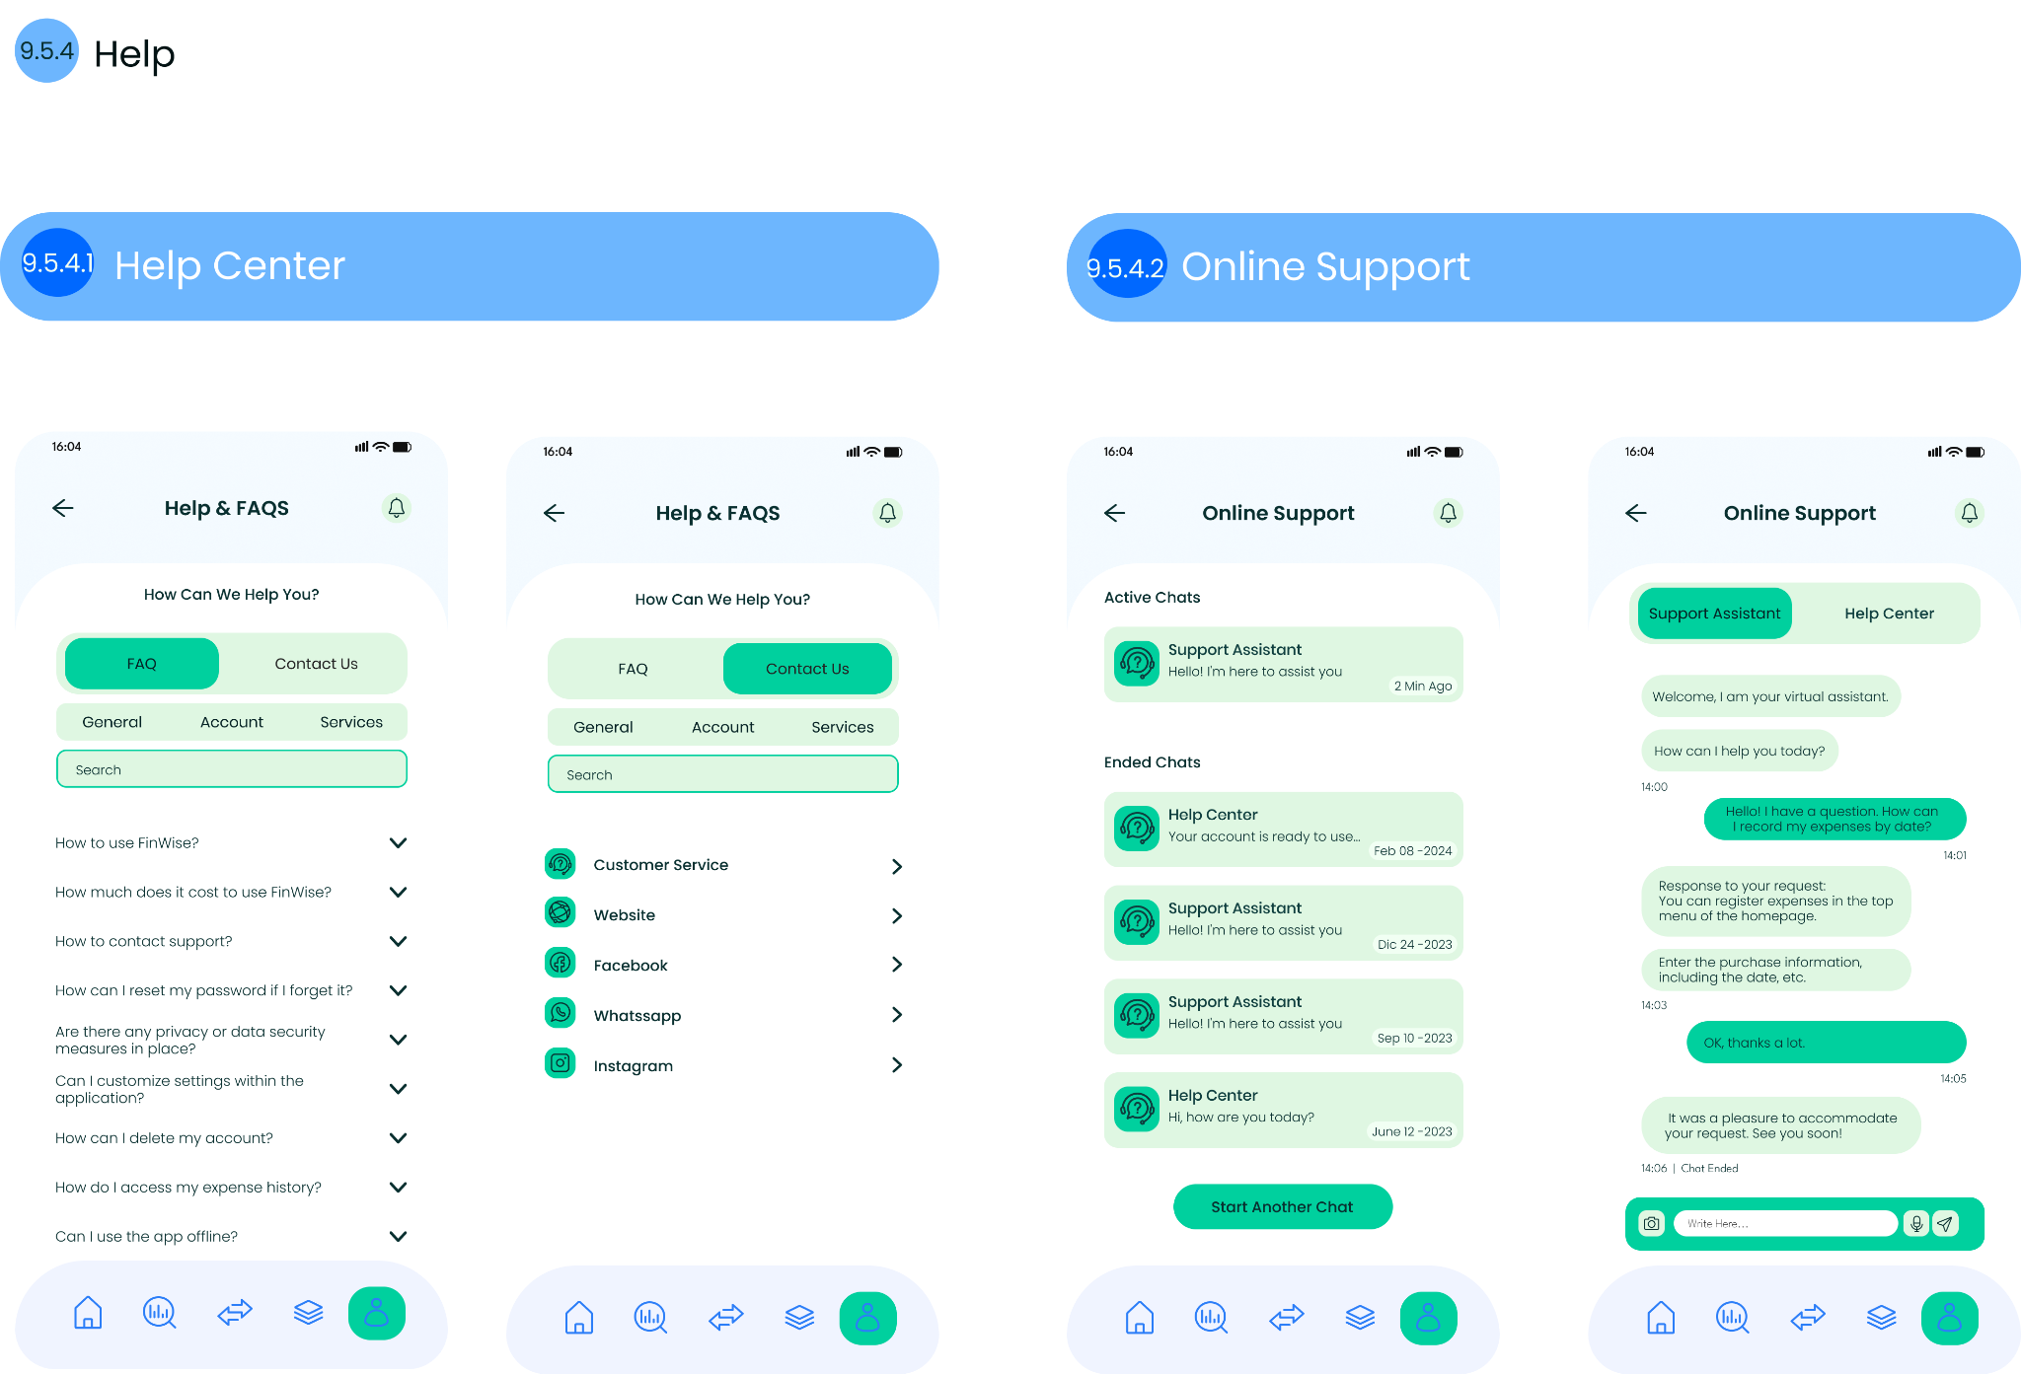

## **Chapter 6**

## **Style Guide (UI Components, Typography, Color Scheme)**

* **Typography** (Primary & secondary fonts).

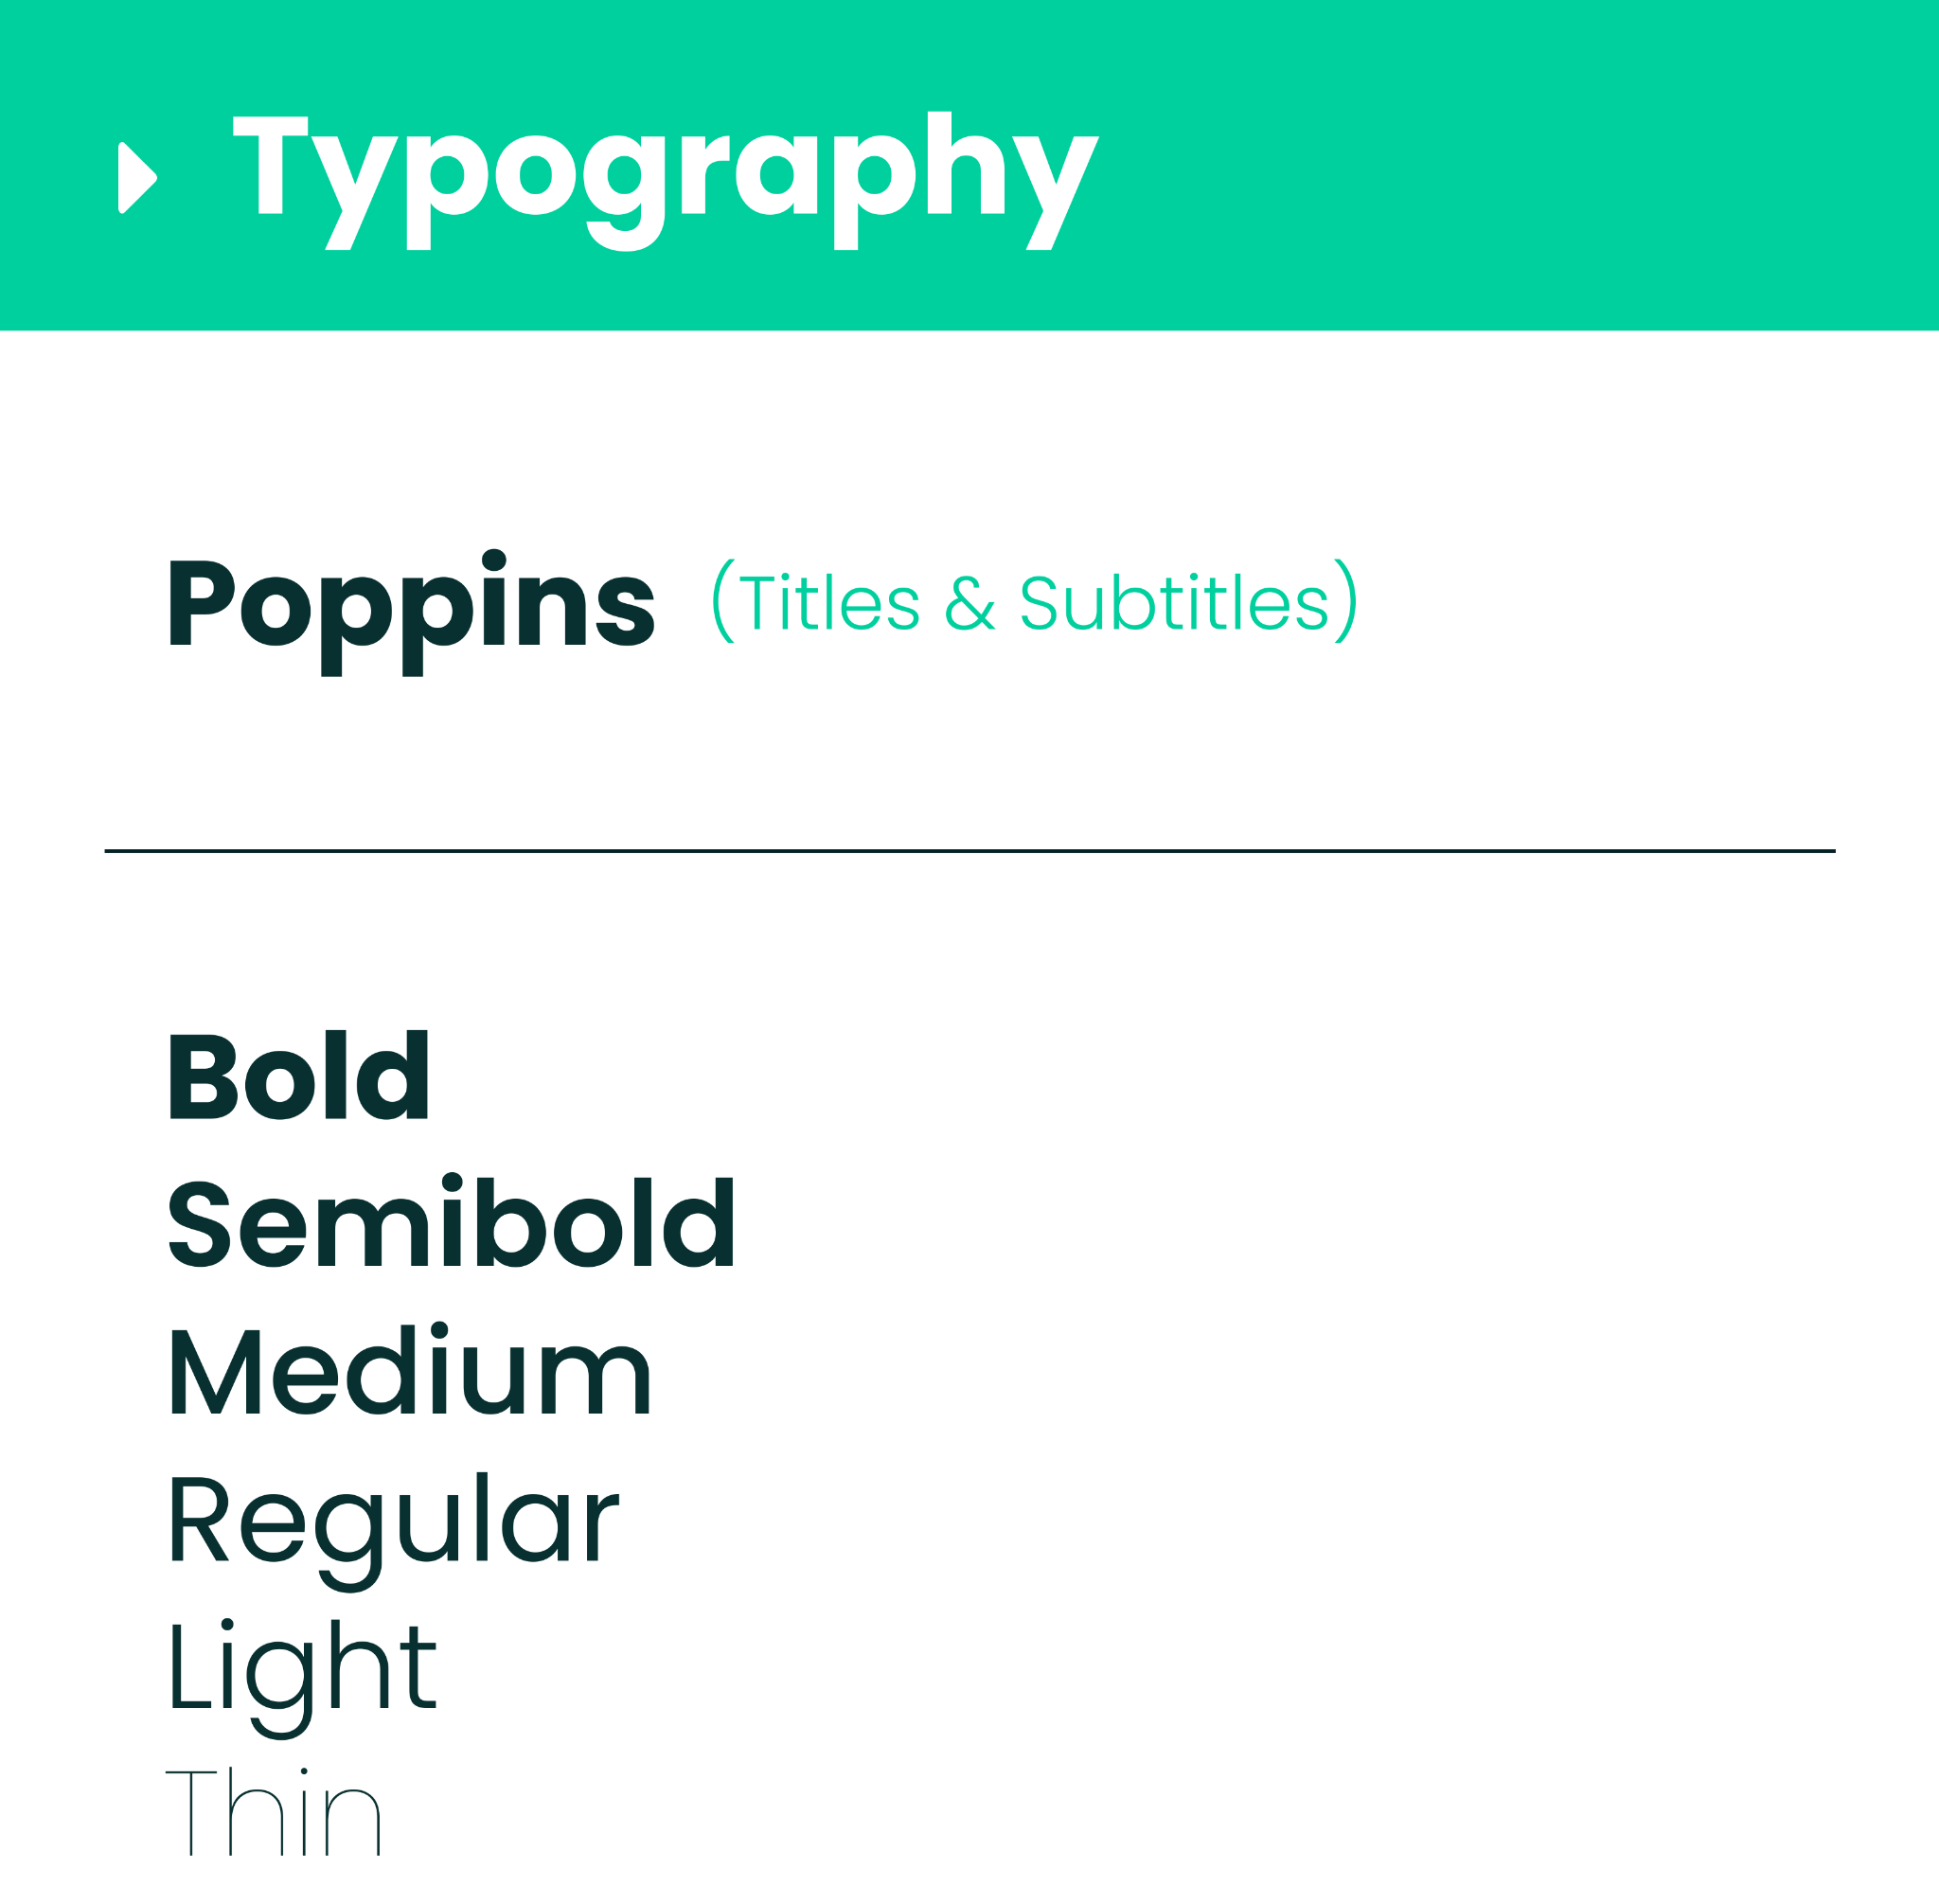



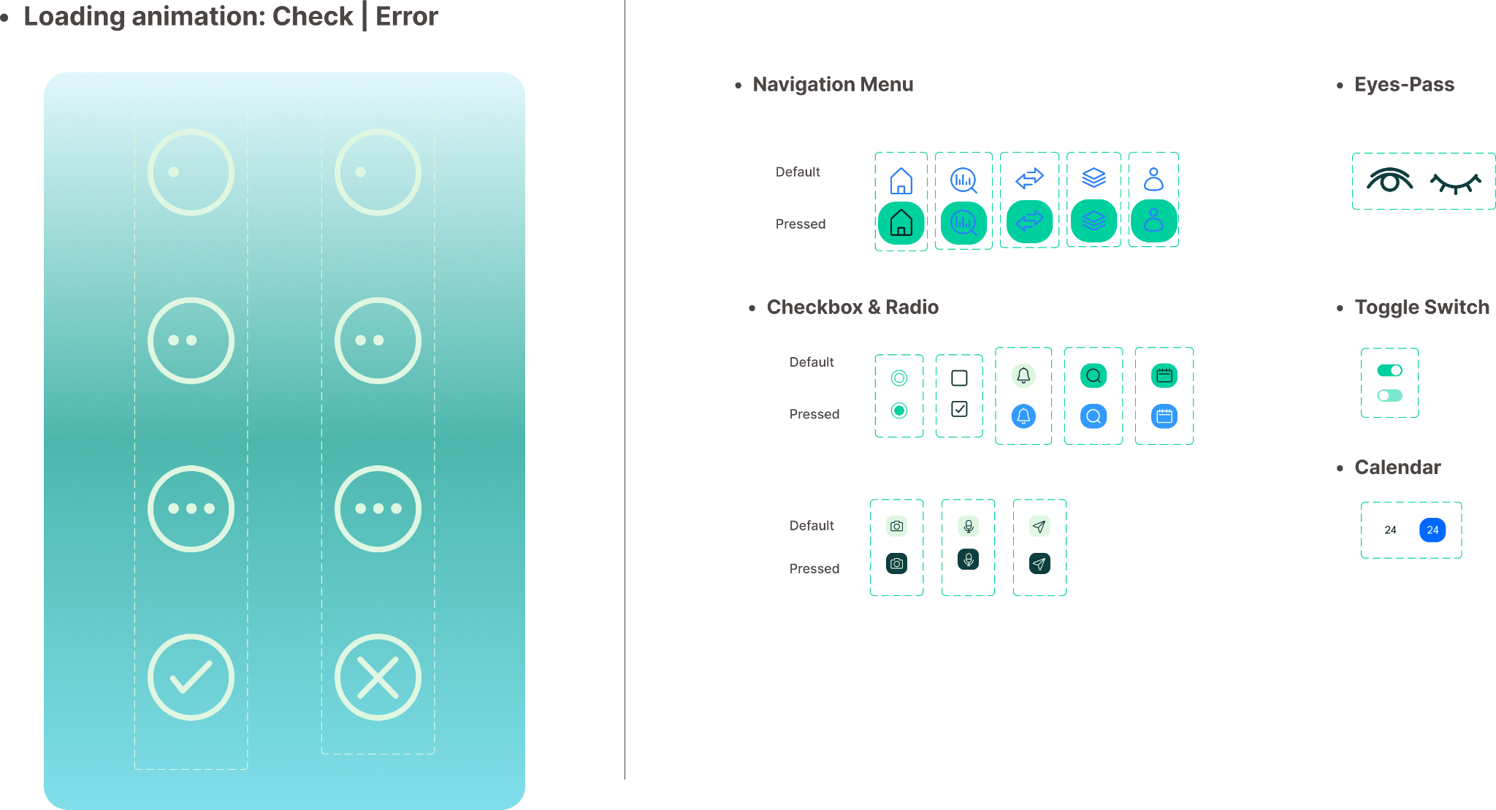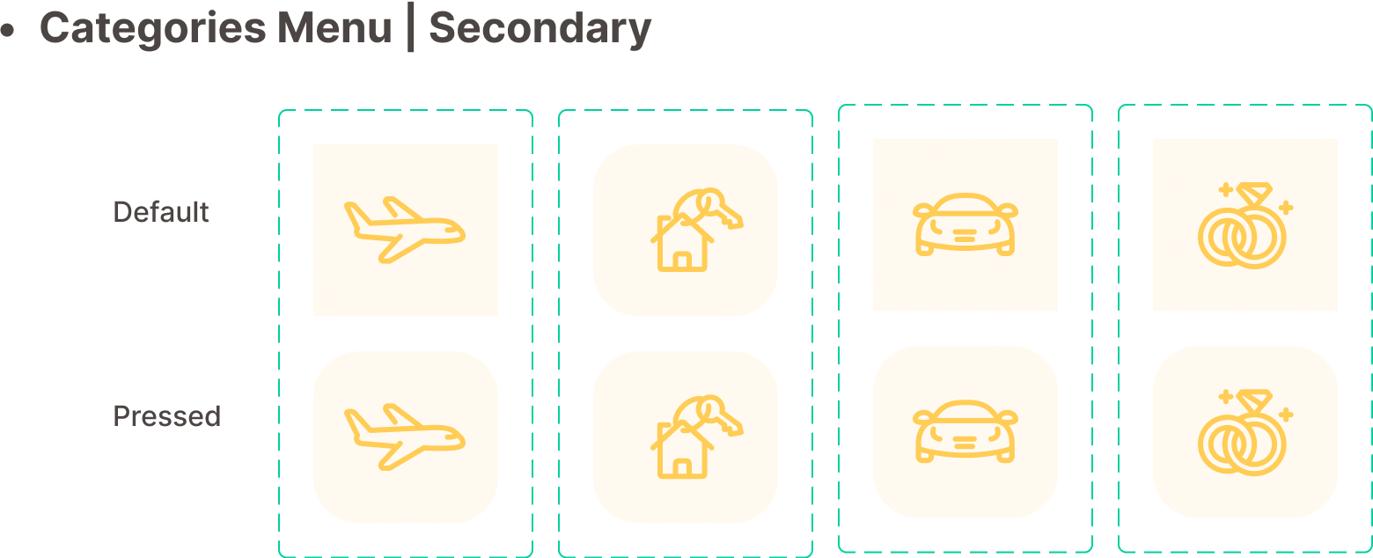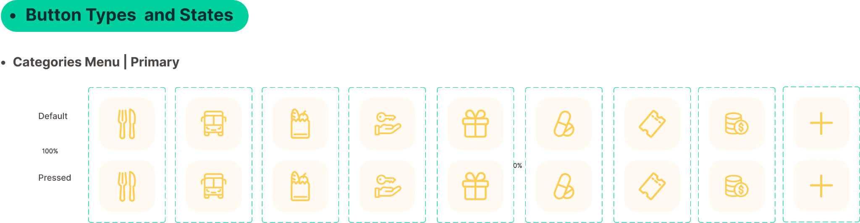

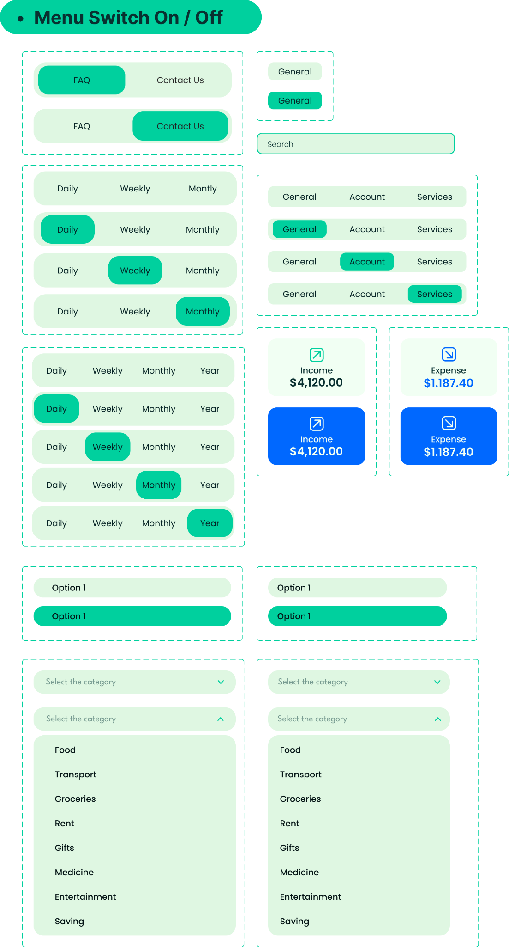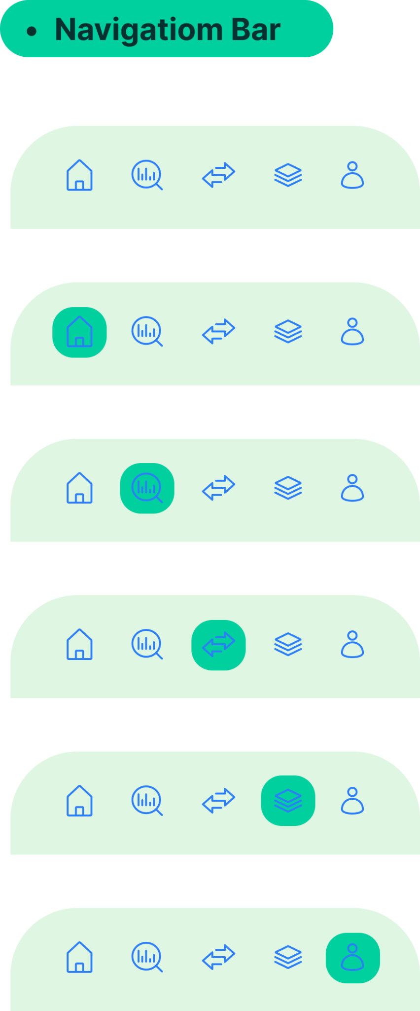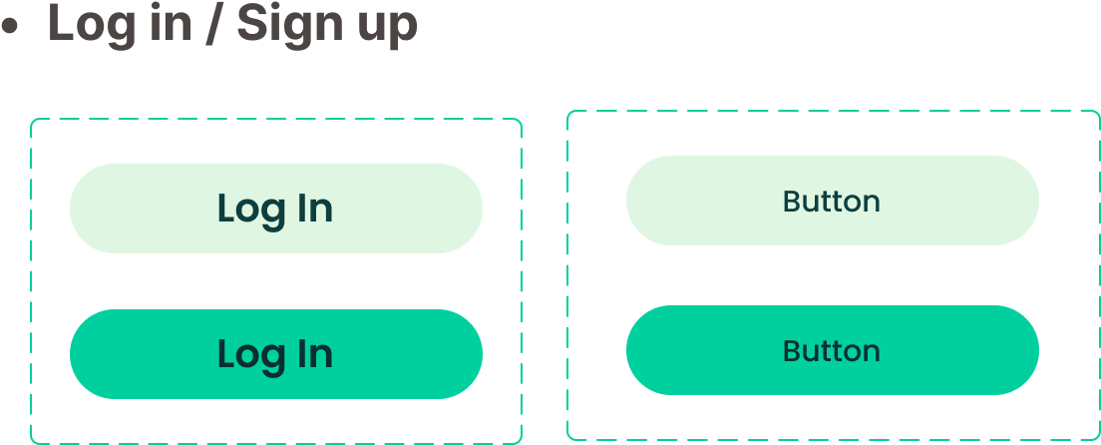

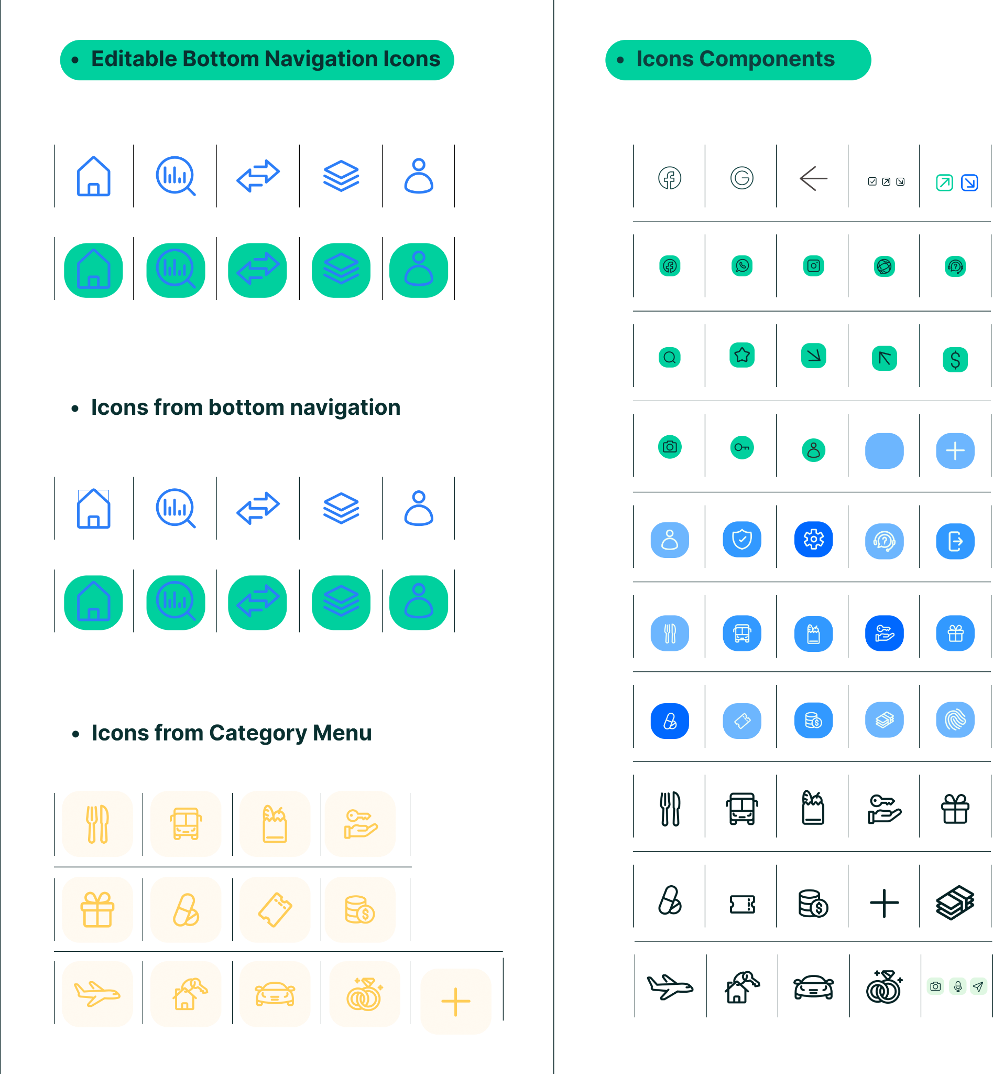

## 

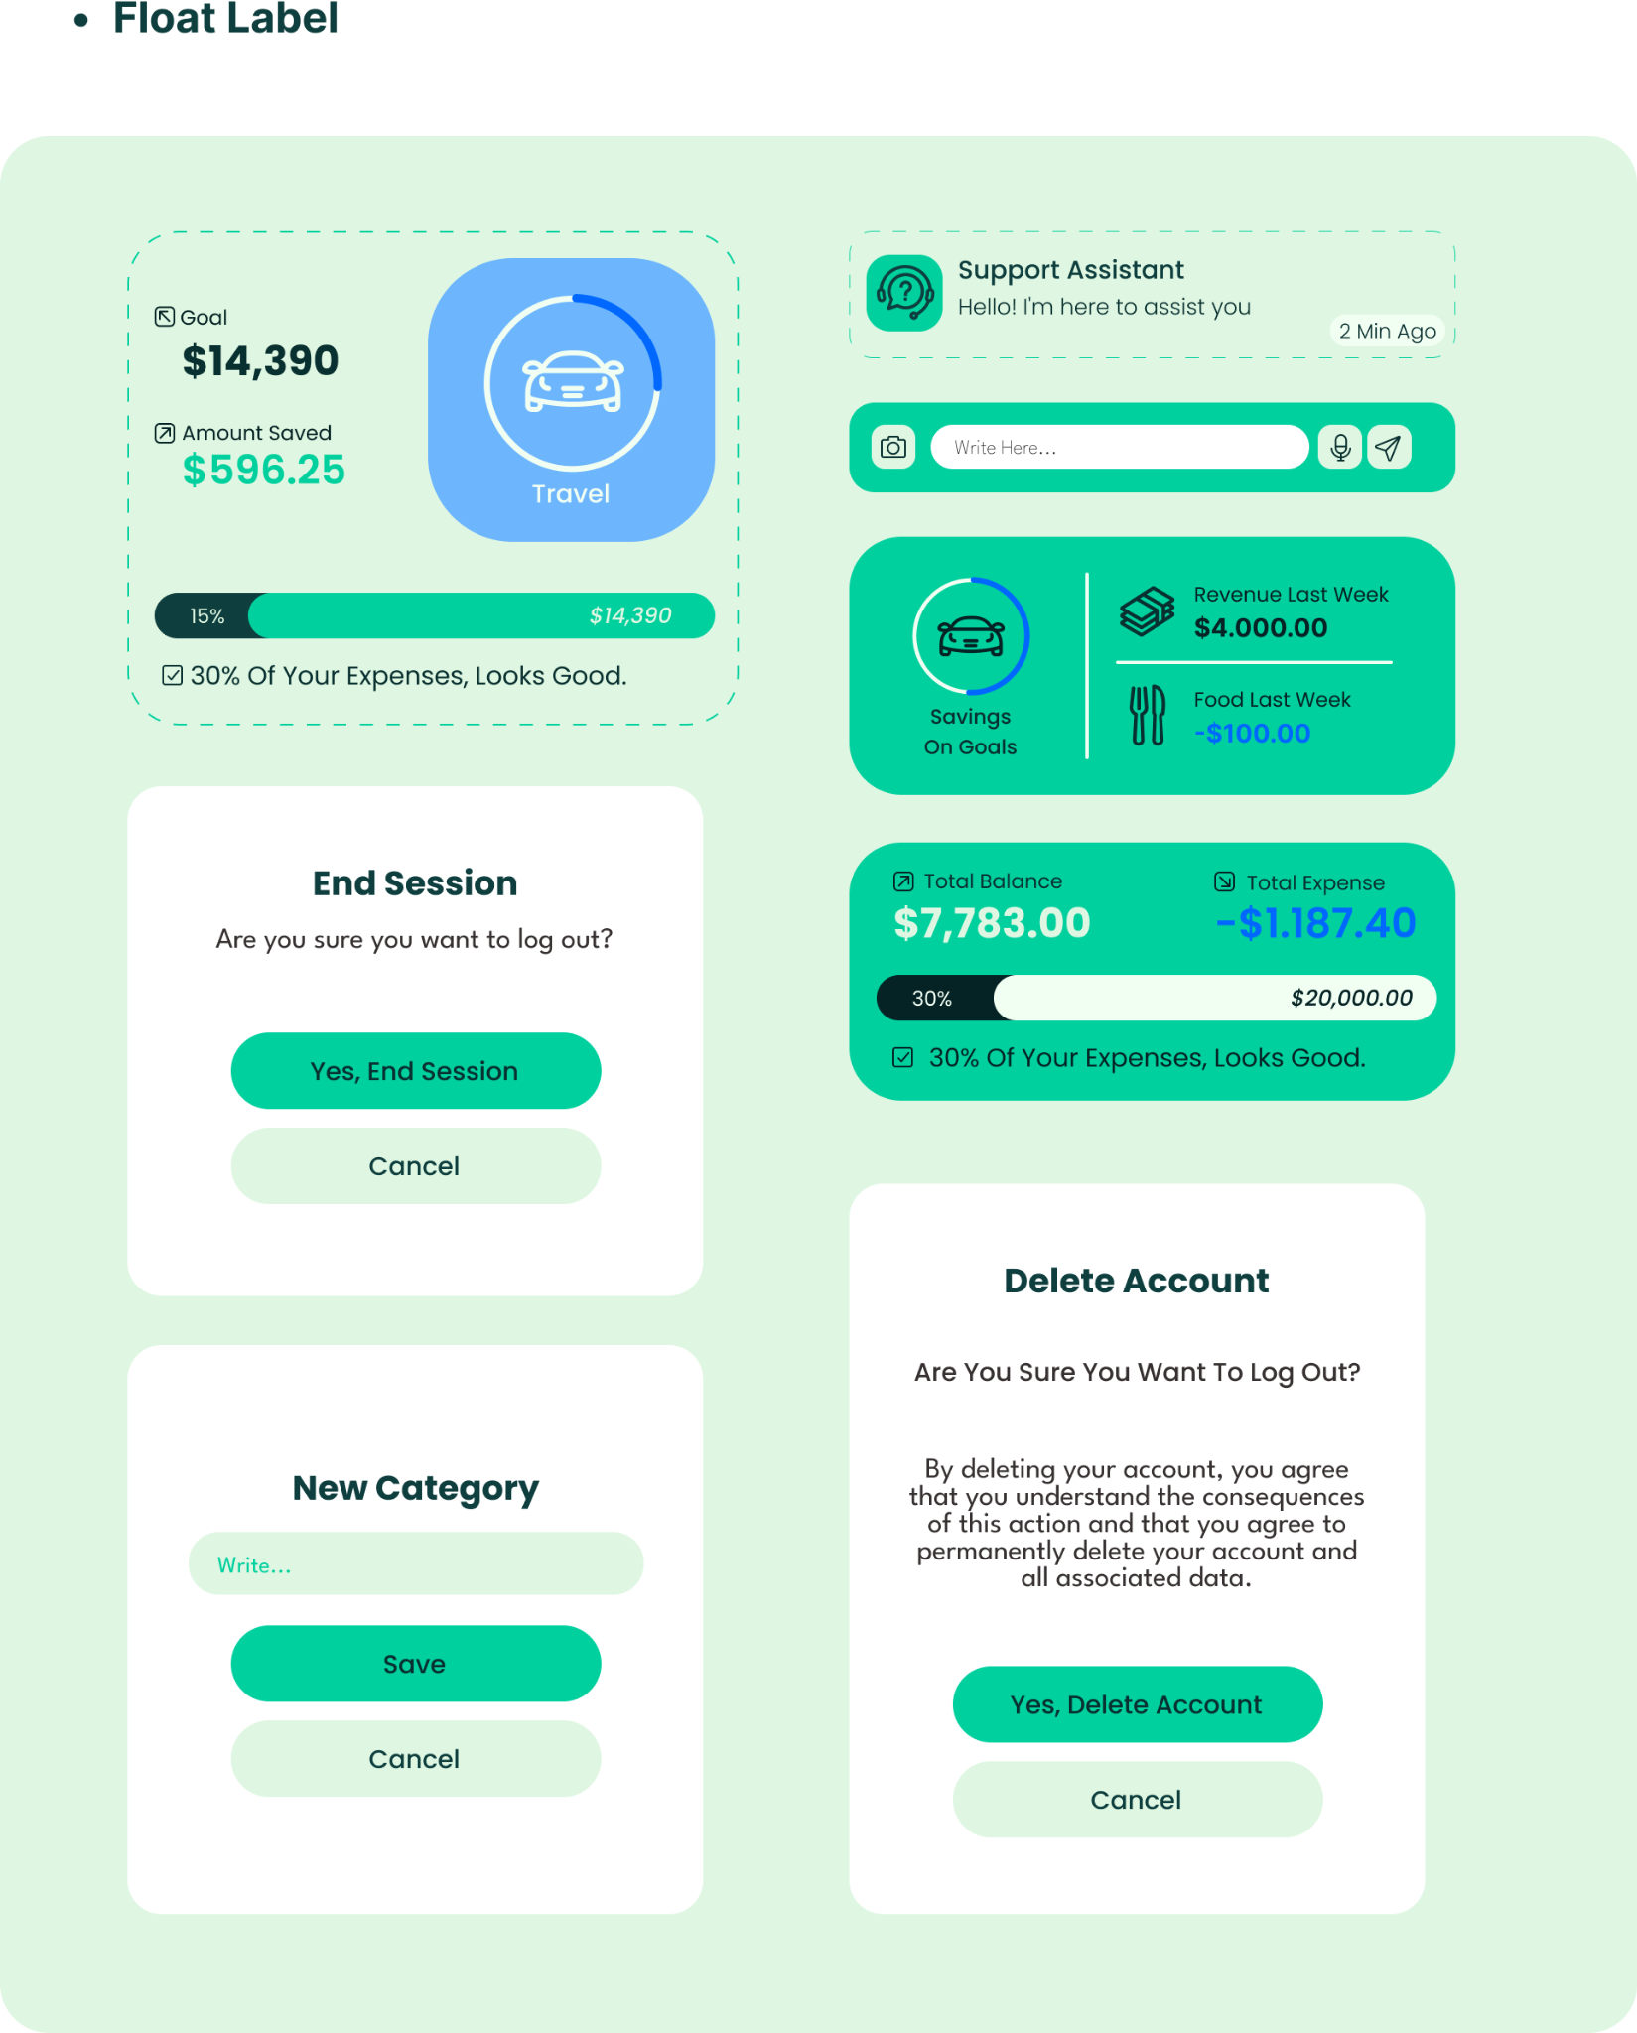

## 

## 

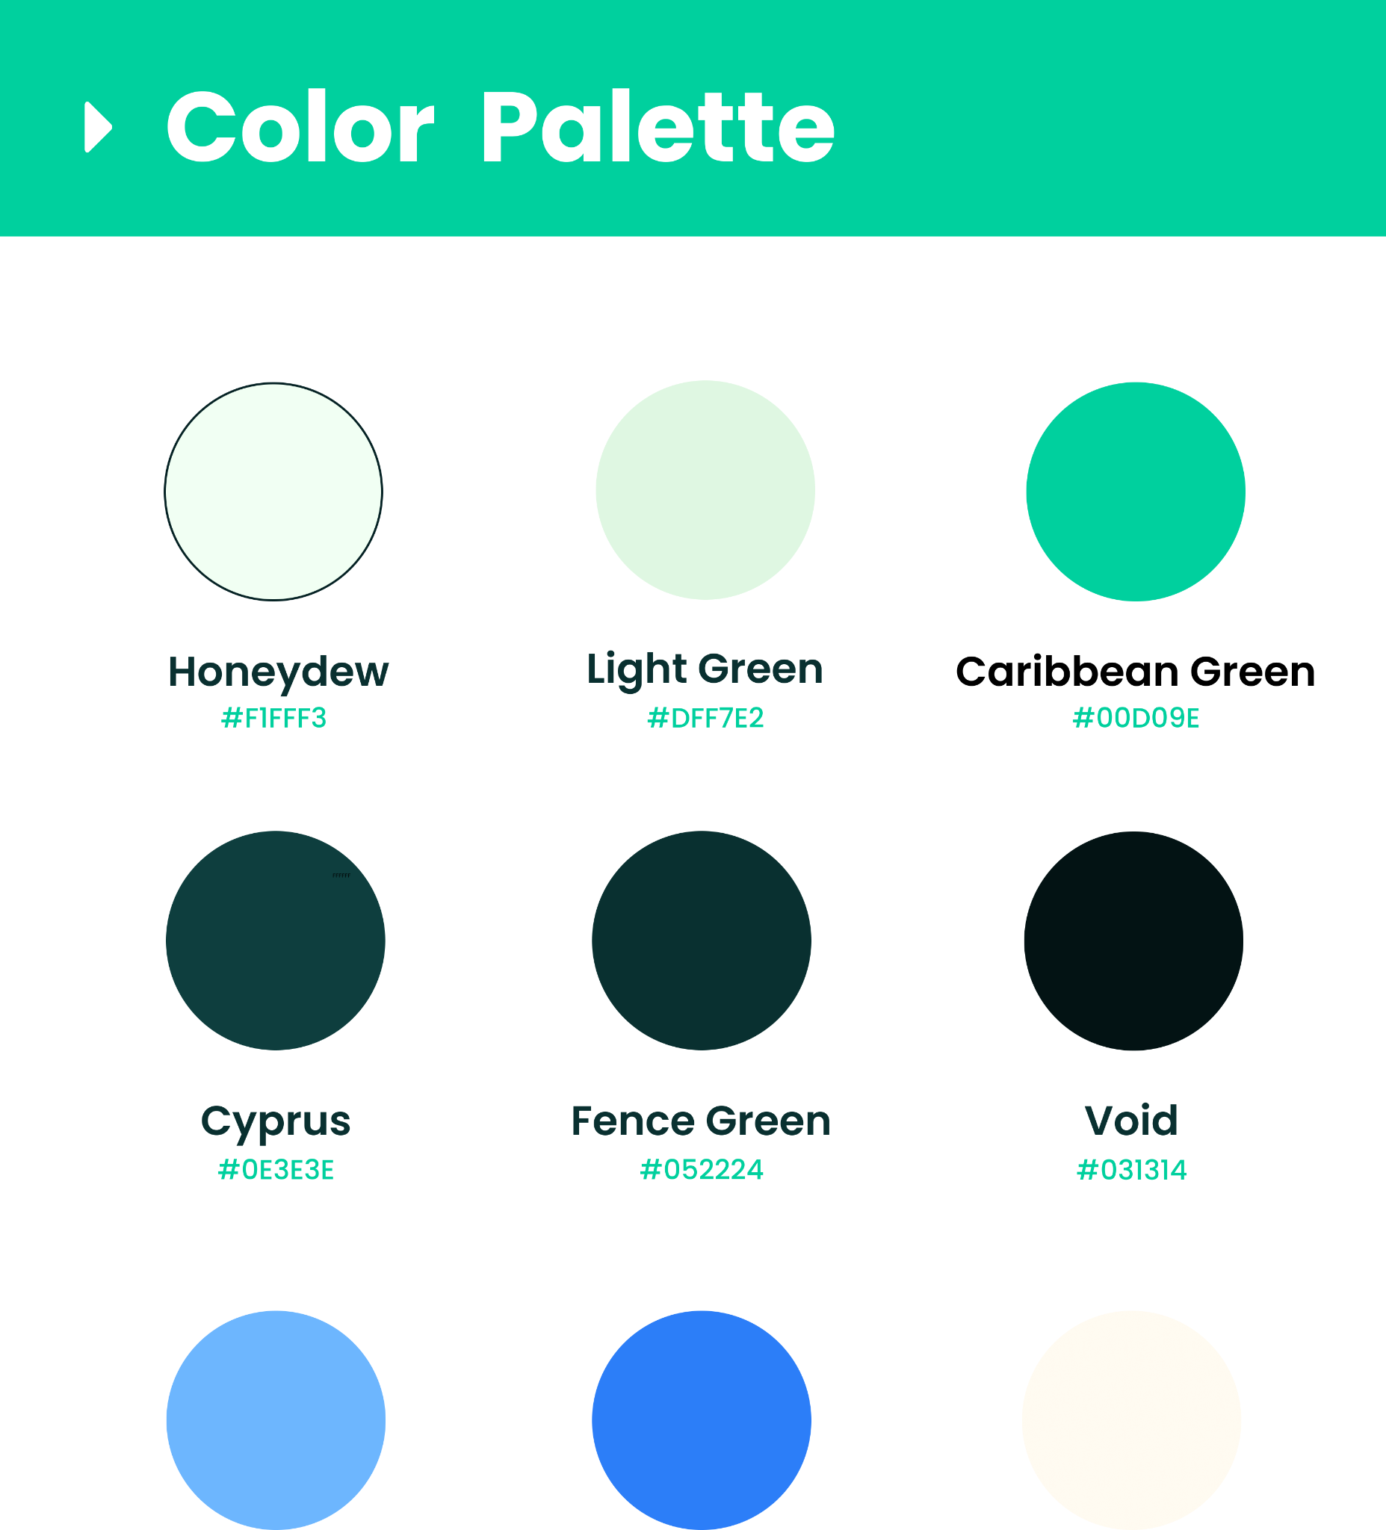

## 

## 

## **Chapter 7**

### **Findings, Designs & Improvements**

**7.1 Key Research Insights**

Based on the UX research (as outlined hypothetically in Chapter 2), the following key insights have significantly influenced the design of Finlytic:

* **Need for Simplicity:** Users expressed a strong desire for a simple and intuitive interface to avoid the complexities often associated with financial management tools. This emphasizes the importance of clean layouts, clear navigation, and straightforward language throughout the app.
* **Importance of Visual Clarity:** Users highlighted the need for clear data visualization to quickly understand their financial status and spending patterns. This led to the incorporation of charts, graphs, and easily digestible summaries within the app.
* **Streamlined Onboarding:** Recognizing the potential for user drop-off during complex onboarding processes, the design focuses on a quick and easy account creation flow.
* **Efficient Transaction Tracking:** The design prioritizes easy transaction input and categorization to address the common pain point of manual tracking.
* **Personalized Insights:** To encourage user engagement and promote better financial habits, the app provides personalized insights and feedback, such as spending summaries and savings goal progress.

**7.2 Final Design Showcase**

The final design of Finlytic, as showcased in the Figma prototype, reflects these key research insights. Here are some representative screenshots:

* **Login/Signup:** Clean and simple screens for user authentication, with options for fingerprint access to enhance convenience.
* **Dashboard:** An overview of the user's financial status, including account balance, recent transactions, spending analysis, and savings goals, presented in a visually appealing and easy-to-understand format.
* **Transaction Management:** Intuitive screens for recording income and expenses, categorizing transactions, and viewing transaction history.
* **Analysis and Reports:** Visualizations of spending patterns, income and expense trends, and progress towards savings goals, enabling users to gain valuable financial insights.
* **Savings Goals:** Features to set and track savings goals, helping users stay motivated and achieve their financial objectives.
* **Profile and Settings:** User-friendly screens for managing account information, security settings, notifications, and app preferences.
* **Help and Support:** Resources for users to find answers to frequently asked questions and access customer support.

**7.3 Future Improvements**

Based on potential user feedback and further iterations, the following improvements could be considered for future development:

* **Enhanced Personalization:** Implement more advanced personalization features, such as AI-powered financial advice, customized budgeting recommendations, and predictive analysis of spending habits.
* **Integration with Financial Institutions:** Explore the possibility of integrating with banks and other financial institutions to automate transaction imports and provide a more comprehensive view of the user's financial landscape.
* **Gamification:** Incorporate gamification elements, such as rewards, badges, and challenges, to increase user engagement and motivation in managing their finances.
* **Accessibility Enhancements:** Conduct thorough accessibility testing and implement features to ensure the app is usable by individuals with disabilities.
* **Refined Data Visualization:** Continuously improve the clarity and interactivity of data visualizations to provide users with even more actionable insights.
* **User Feedback Mechanisms:** Implement robust mechanisms for gathering user feedback, such as in-app surveys and user testing, to inform ongoing development and improvements.

## **Links**

1)Finlytic Figma Prototype:

[Low Fidelity](https://www.figma.com/proto/6bPu4RZT4ngPko52dbwTVk/Low-Fidelity-Frame?node-id=0-1&t=ASh46K7SwnjKa2Ld-1)

[High Fidelity](https://www.figma.com/proto/M81izmpuFBfQikad8hw3wc/Finlytic_Gaurav-Shreyash-edit?node-id=7020-3430&t=w5vJzcqhOdLZSbCh-1)

2)Finlytic Youtube Video Link :

[Video](https://youtu.be/QhelQqo4JuA)

3)Finlytic Github Link :

[Github](https://github.com/OtakuNoDev/Finlytic)